**ASSIGNMENT**

**MODULE-2**

**FSX**

**DONE BY  
RANJITH KUMAR**

**Problem Statement:**

You work for XYZ Corporation and the current requirement in the organization is for faster file sharing, which can also help in data replication from

on-premises infrastructure.

**Tasks To Be Performed:**

1. Create an FSx file system for a Windows file server:

a. Make sure you have AWS Managed Active Directory with a valid

domain name

b. Connect it to your Windows EC2 server

2. Create an FSx file system for Lustre and attach it to an Amazon Linux 2

instance.

**FSx file system for a Windows file server:**

**STEP 1 :** Open Directory service from aws services

STEP 2 : Select AWS managed Microsoft Ad > Setup directory

STEP 3 : We need an directory while creating an fsx file system for windows file server

STEP 4 : Now created an active directory:-crk.com

STEP 5 : Open EC2 and launch a windows server

STEP 6 : Connect to windows server using RDP client

STEP 7 : select the .pem file and decrypt the password

STEP 8: Connect to windows server

STEP 9 : Open Fsx > create file system

STEP 10 : select deployment type , storage , iops ,throughput ,IOPS , network

Existing directory to create file system

STEP 11 : file system has been created now we have to connect to windows server

STEP 12 : Now go to the windows server

STEP 13 : Open control panel > Network and internet > Network and sharing center > change adapter settings > select ether\net and open properties > double left click on internet protocol version 4 (TCP/IPV4)

STEP 14 : Copy the DNS address from the directory and paste in the internet protocol version4 tab

STEP 15 : To register the domain in our server , Go to Control Panel > System and Security > system > Advance system setting > then click computer name

STEP 16 : Attach the FSX to the server by copying the command in the attach

STEP 17 : Open command prompt in the windows server and paste : net use Z: \\amznfsxn4tm0mcd.crk.com\share in the cmd prompt

STEP 18 : Give user name and password

STEP 19 : Share folder has been created

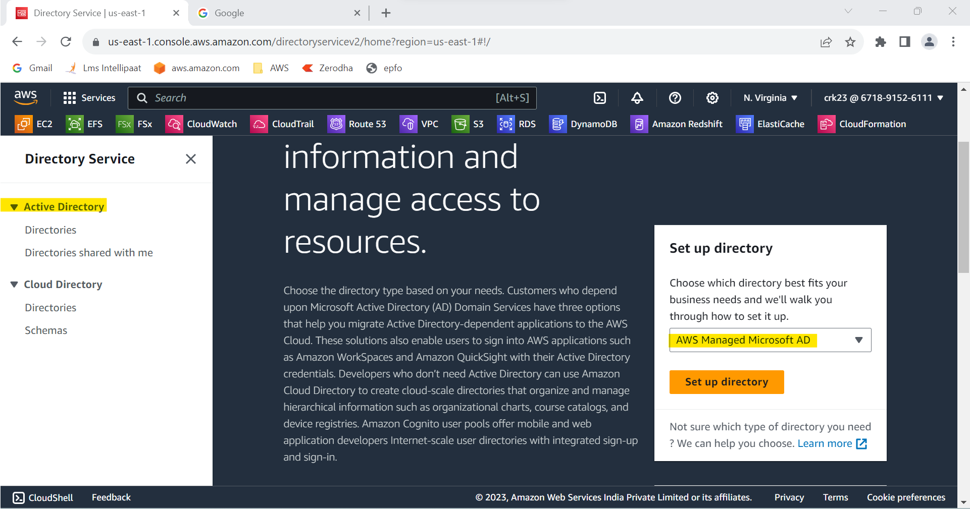

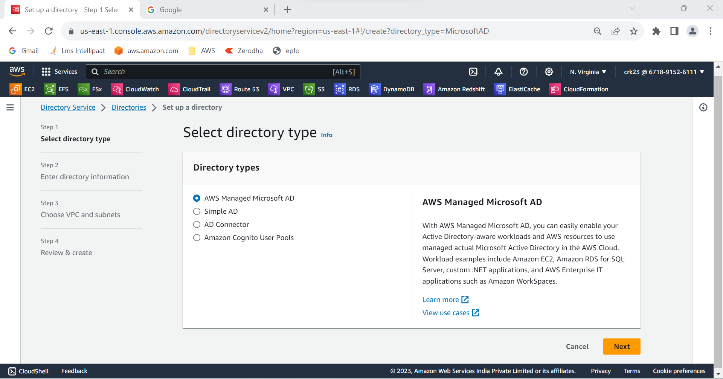

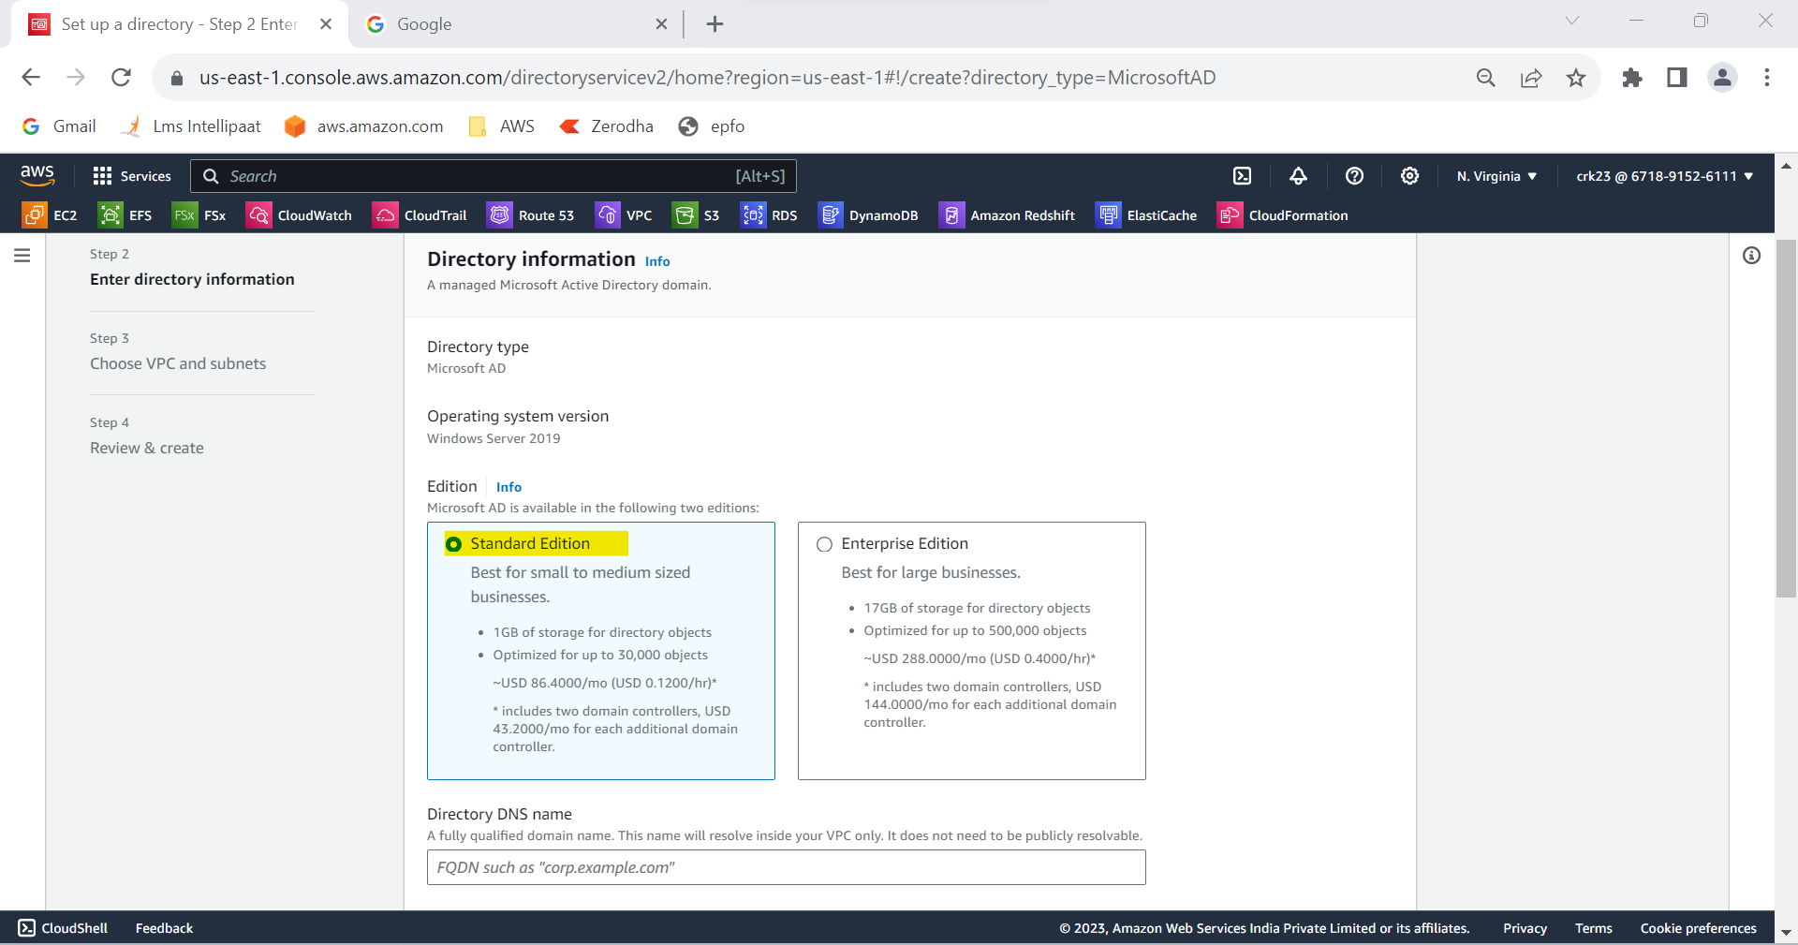

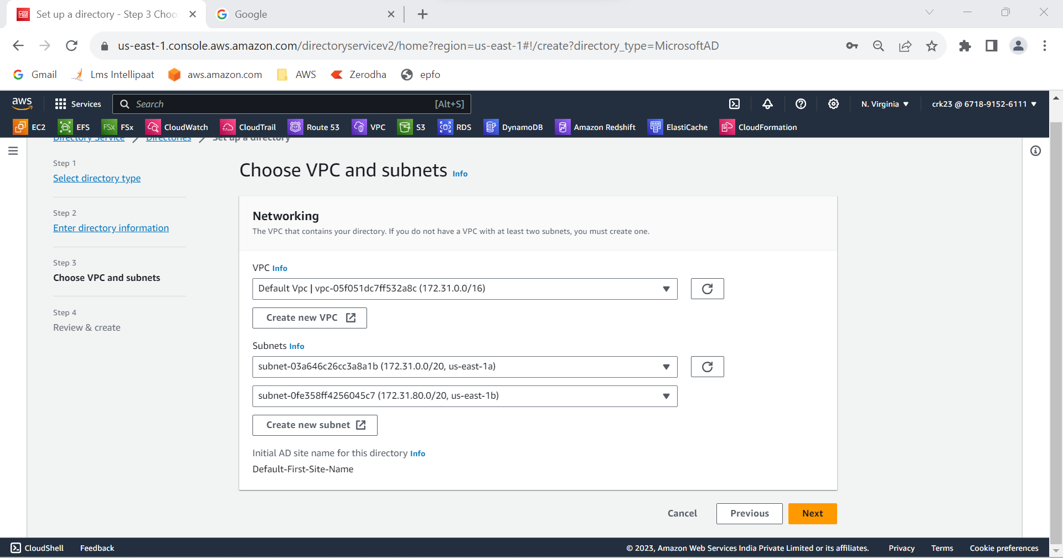

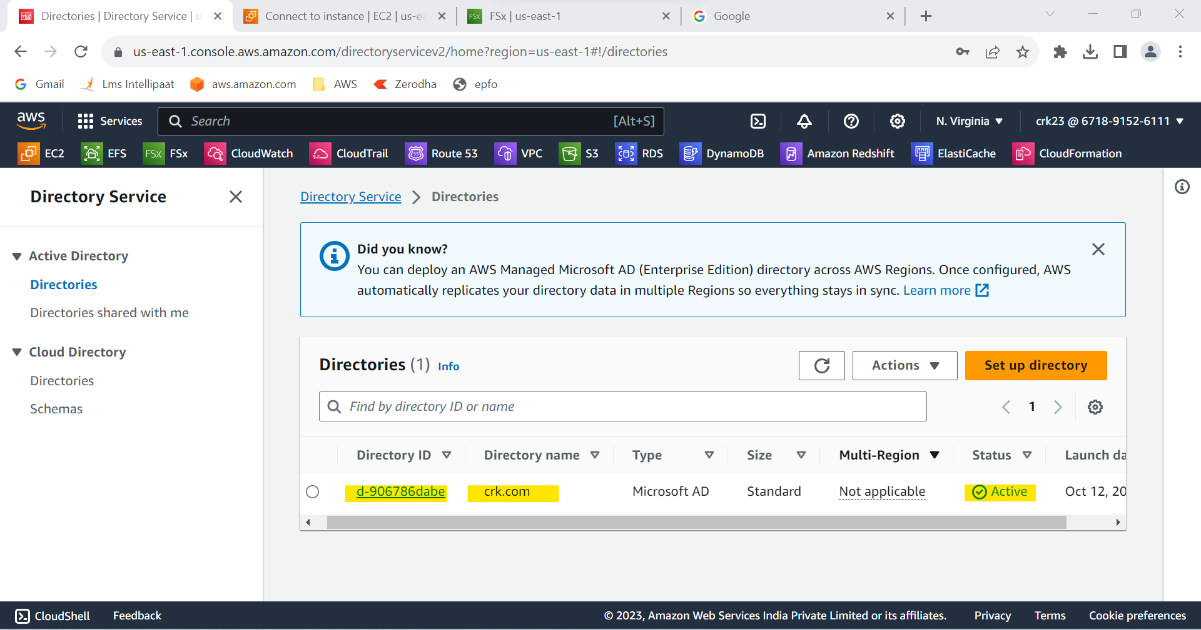

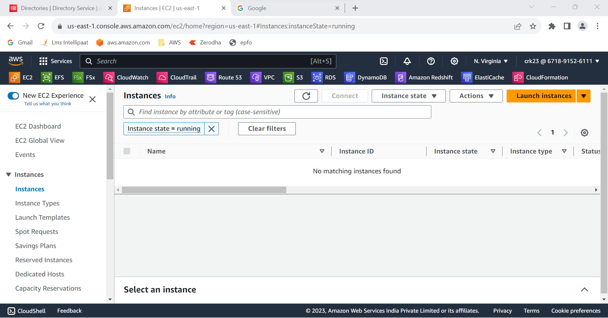

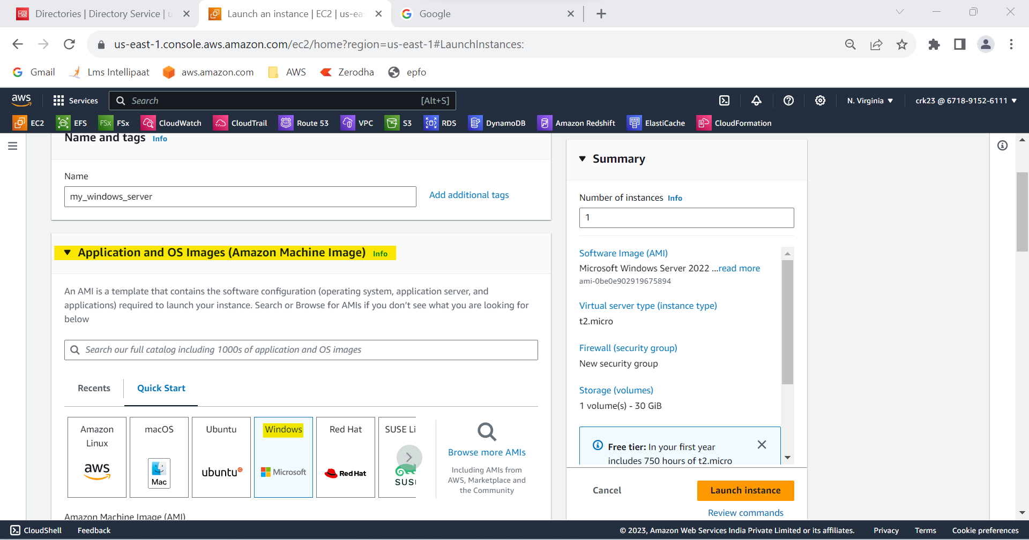

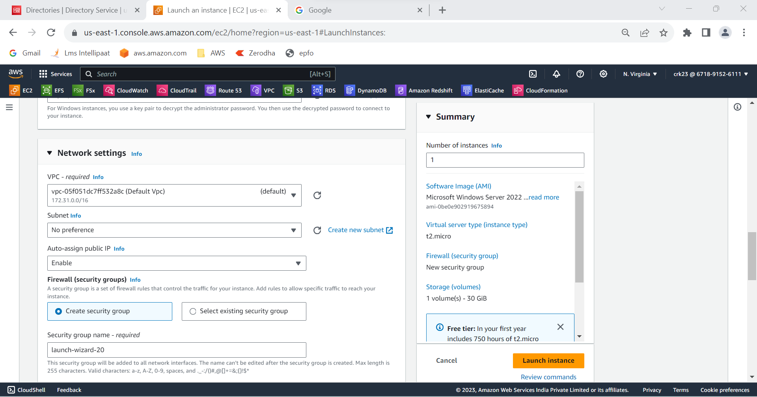

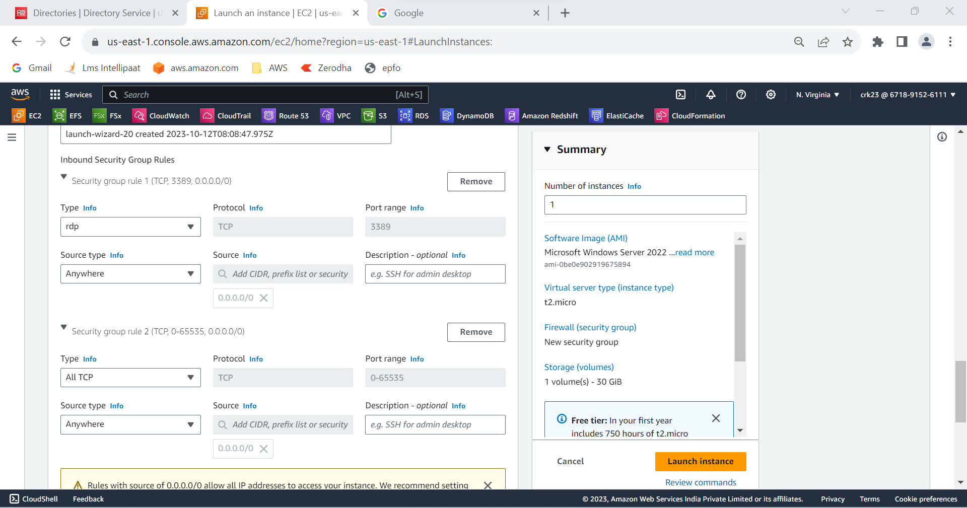

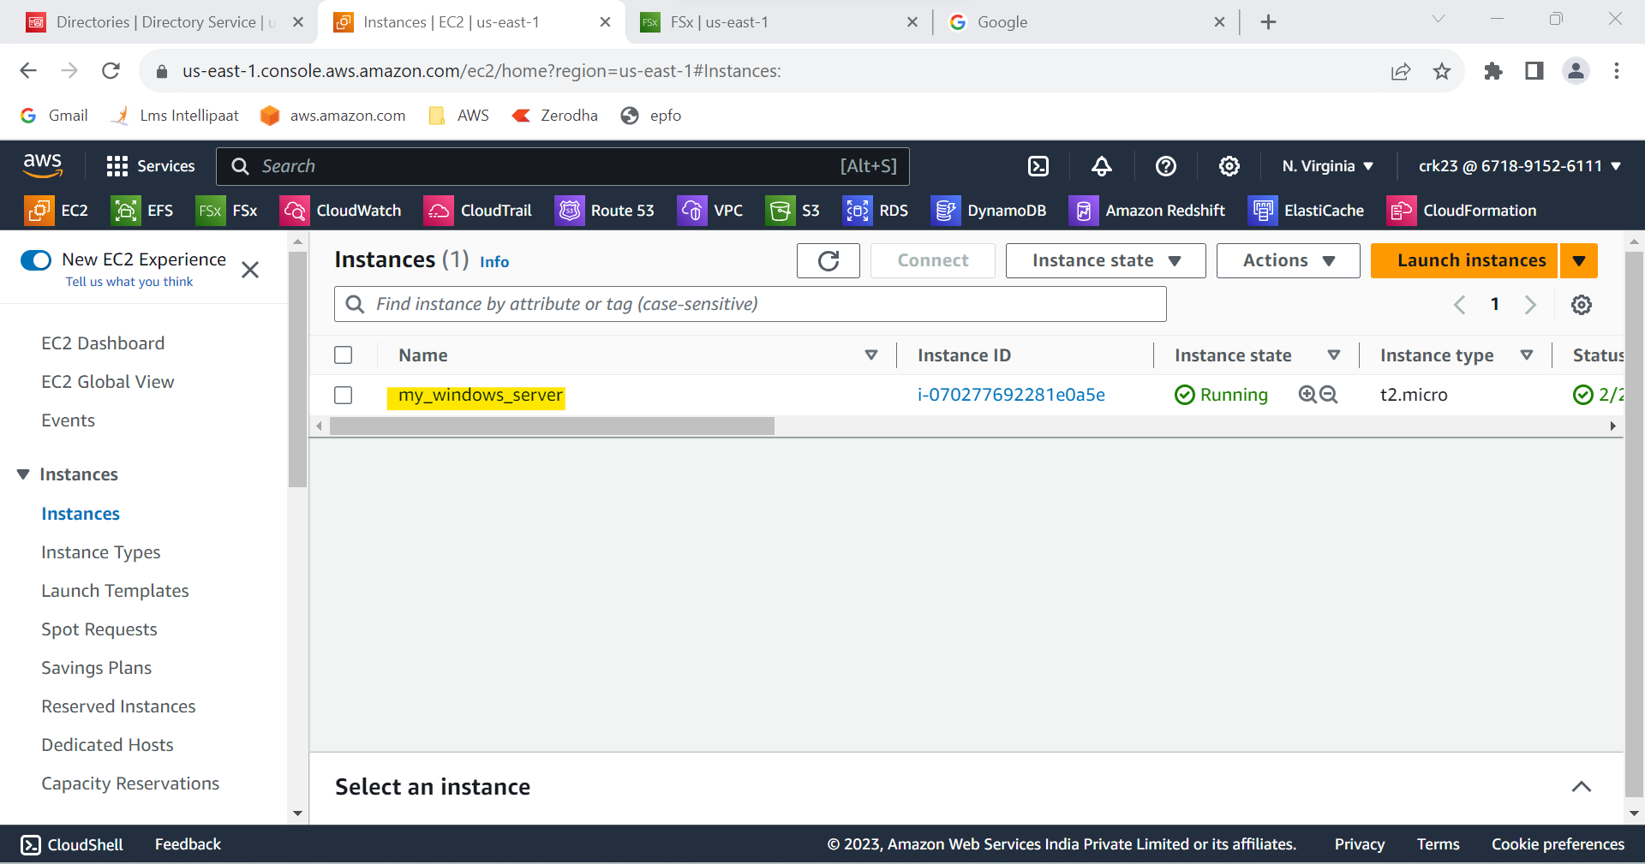

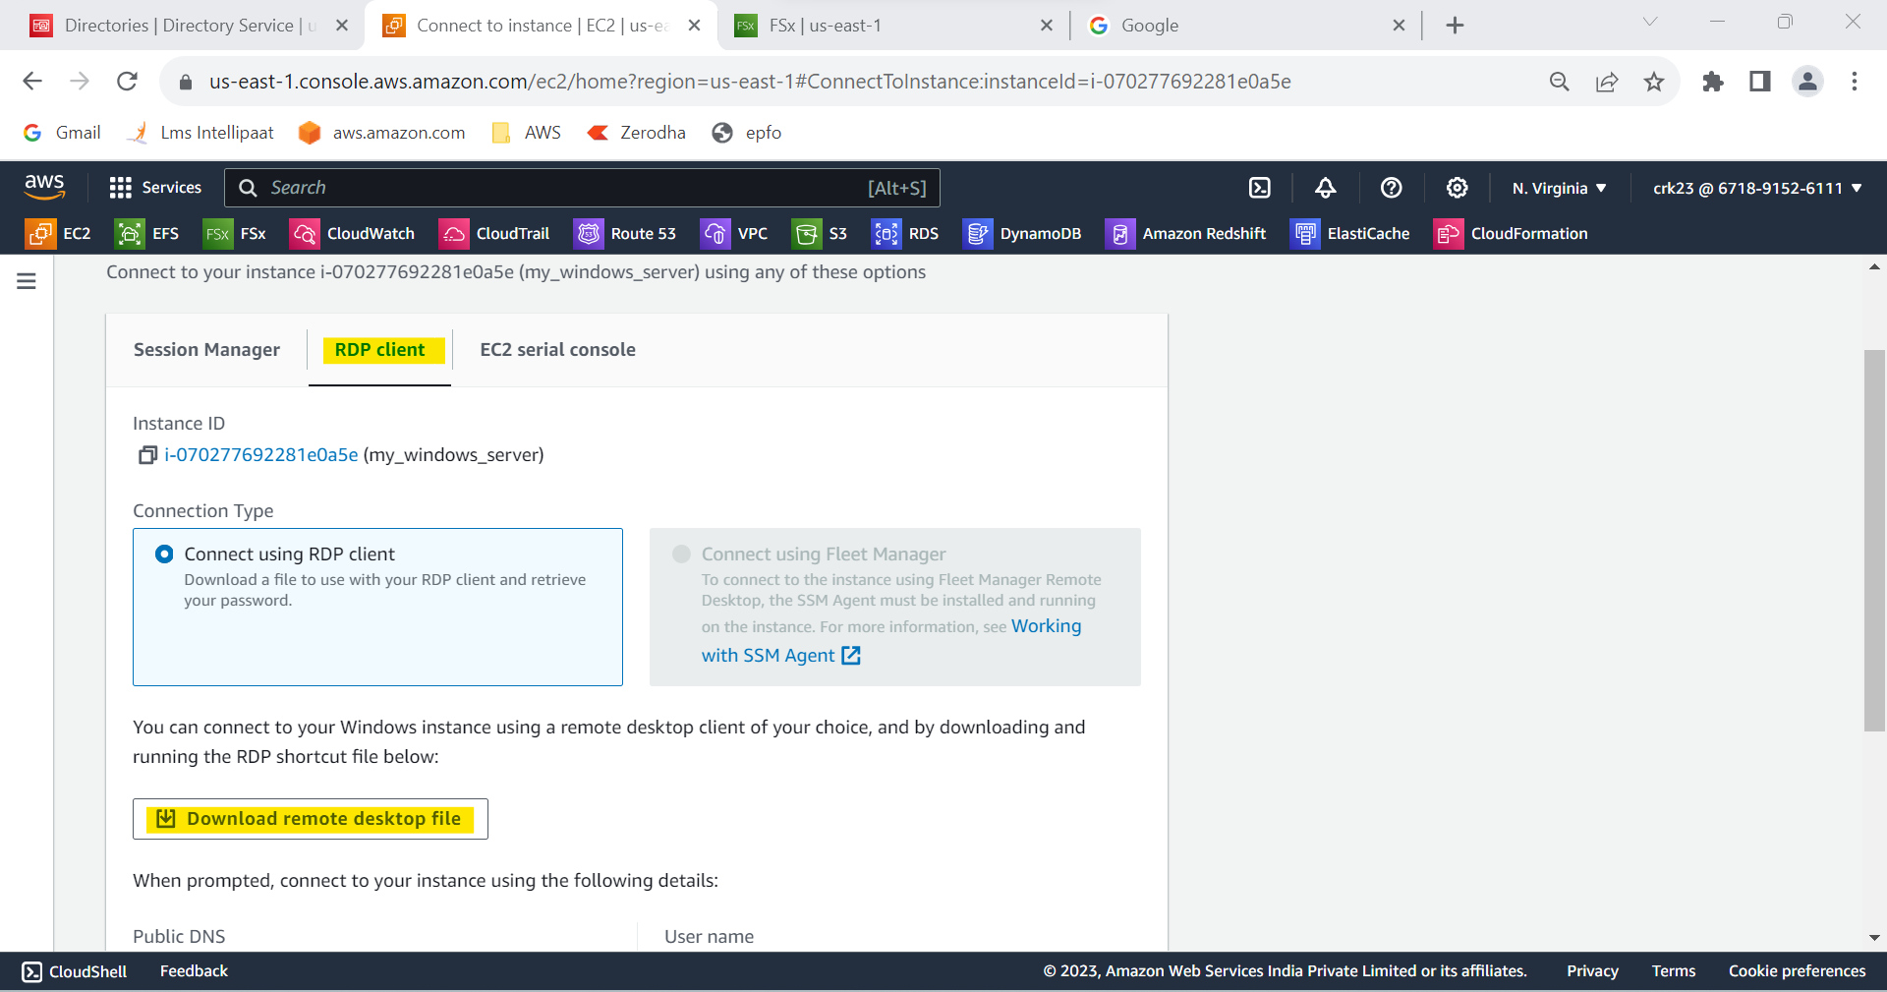

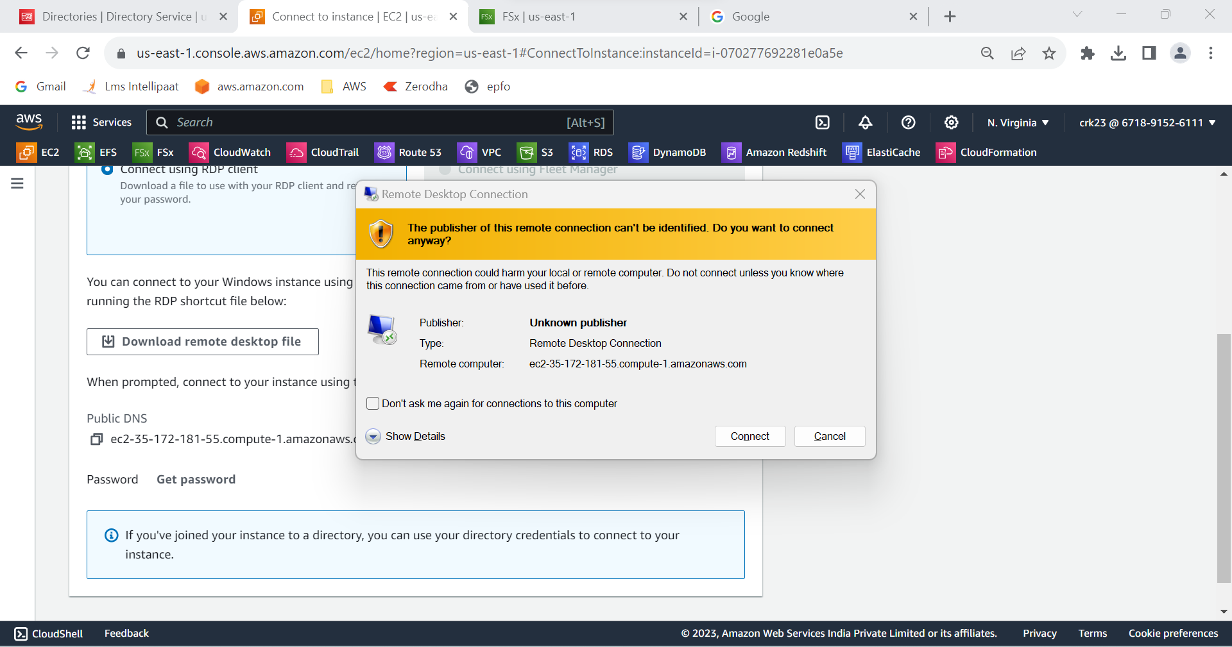

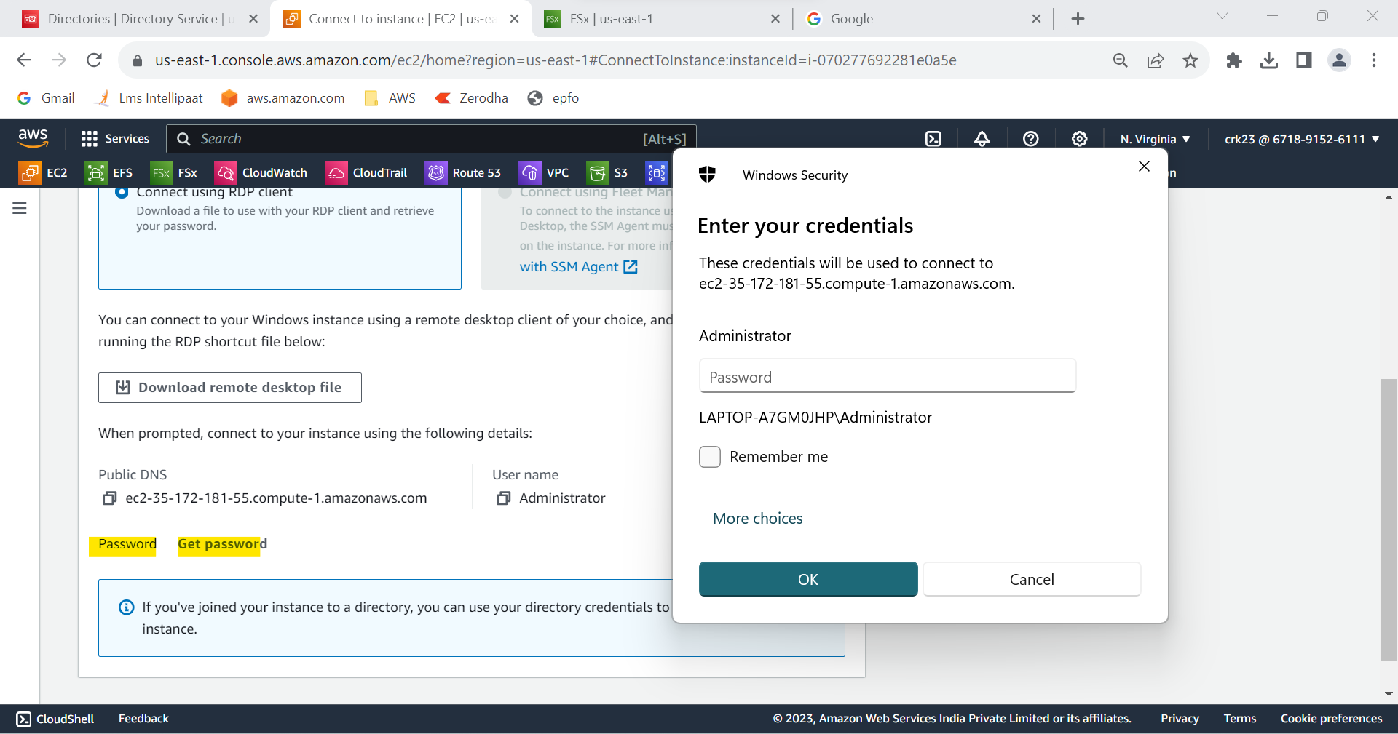

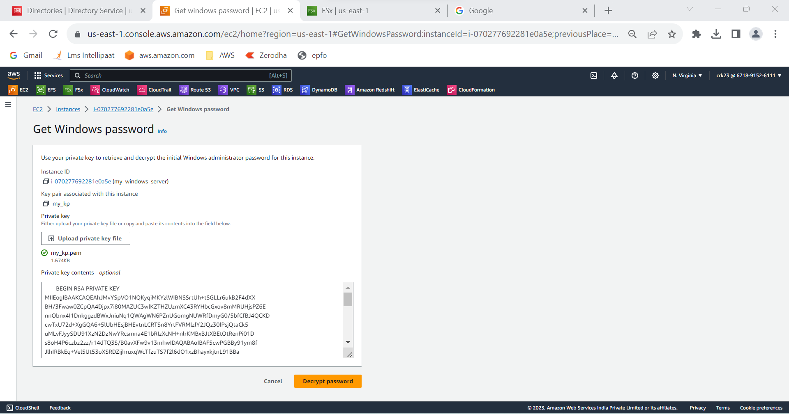

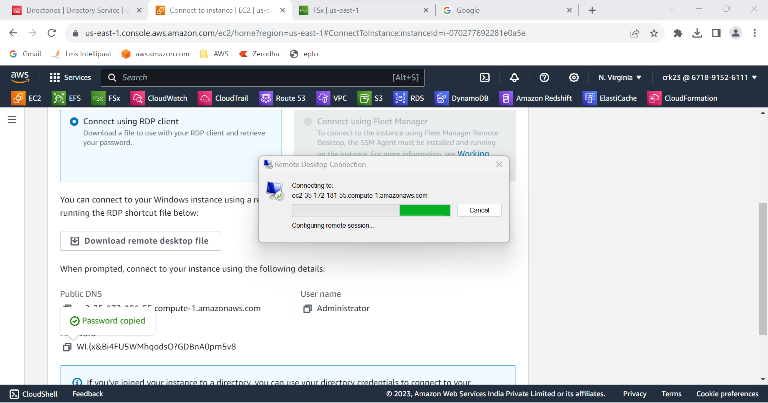

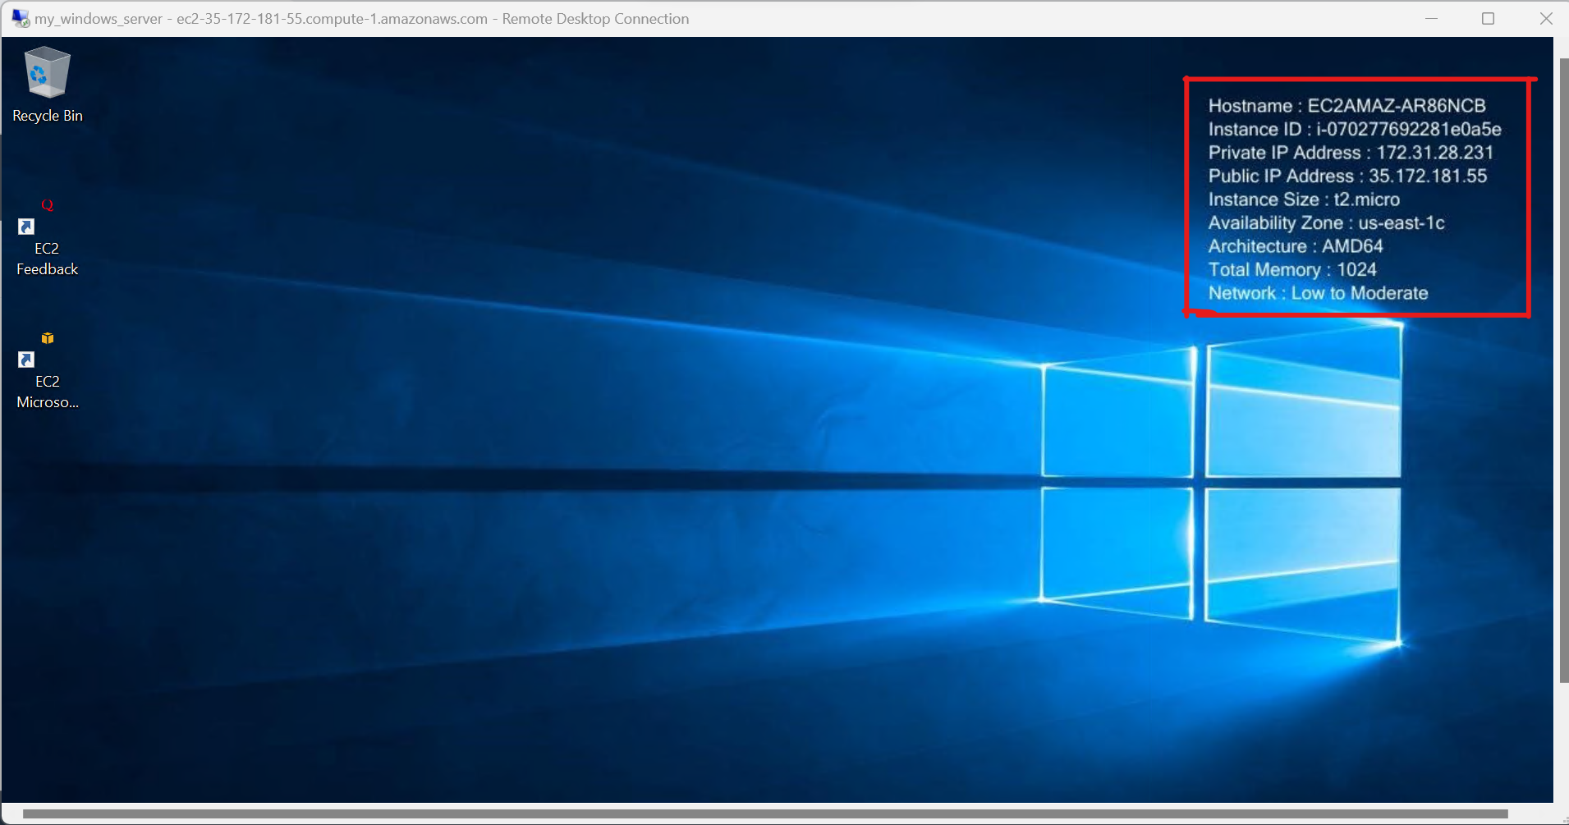

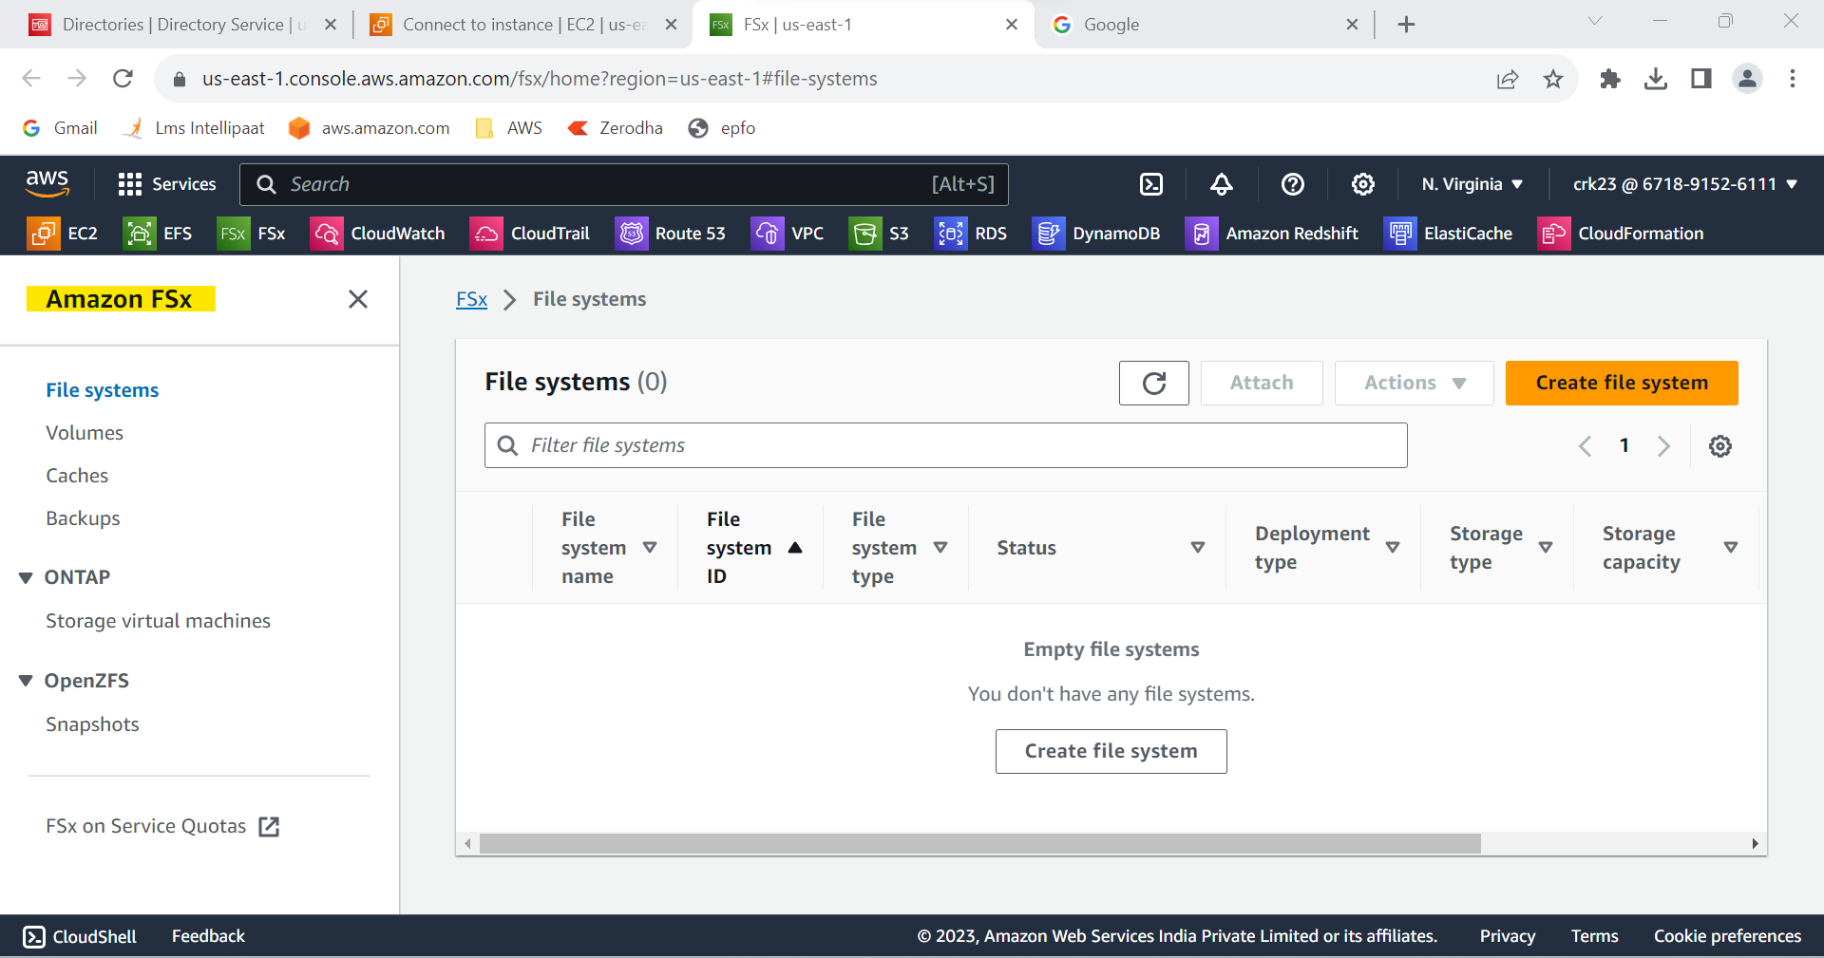

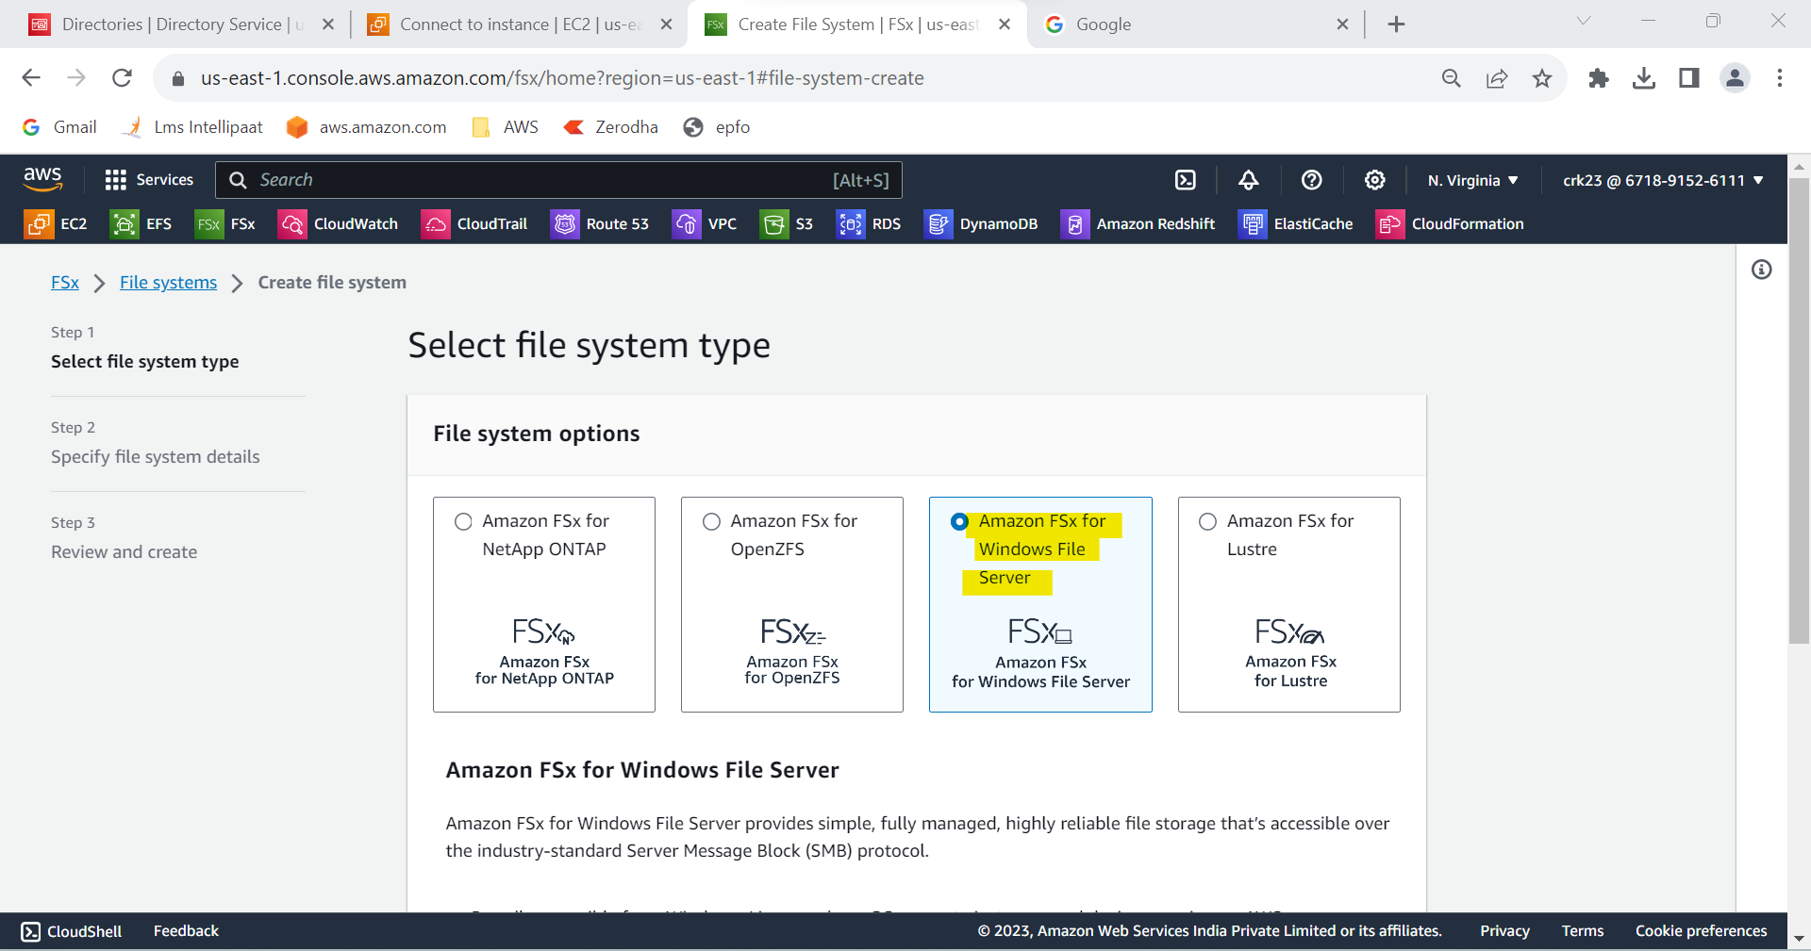

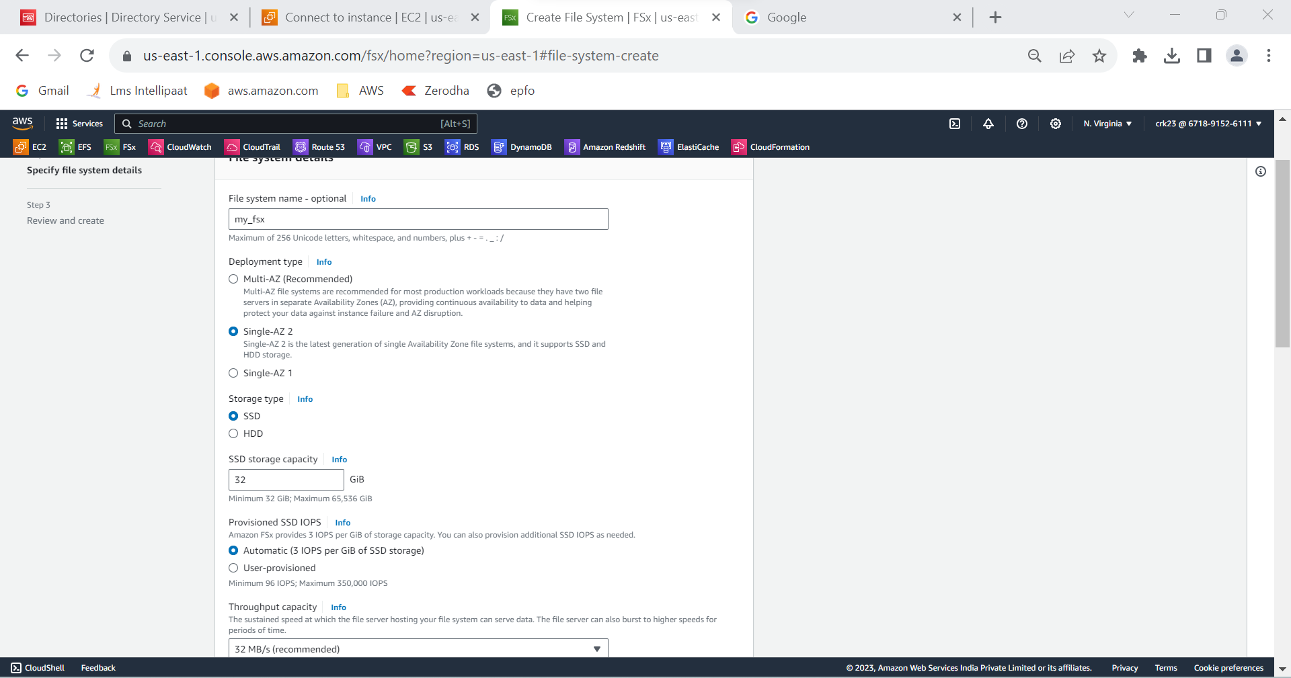

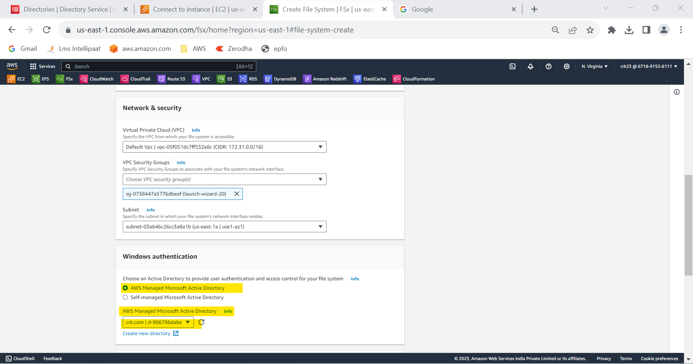

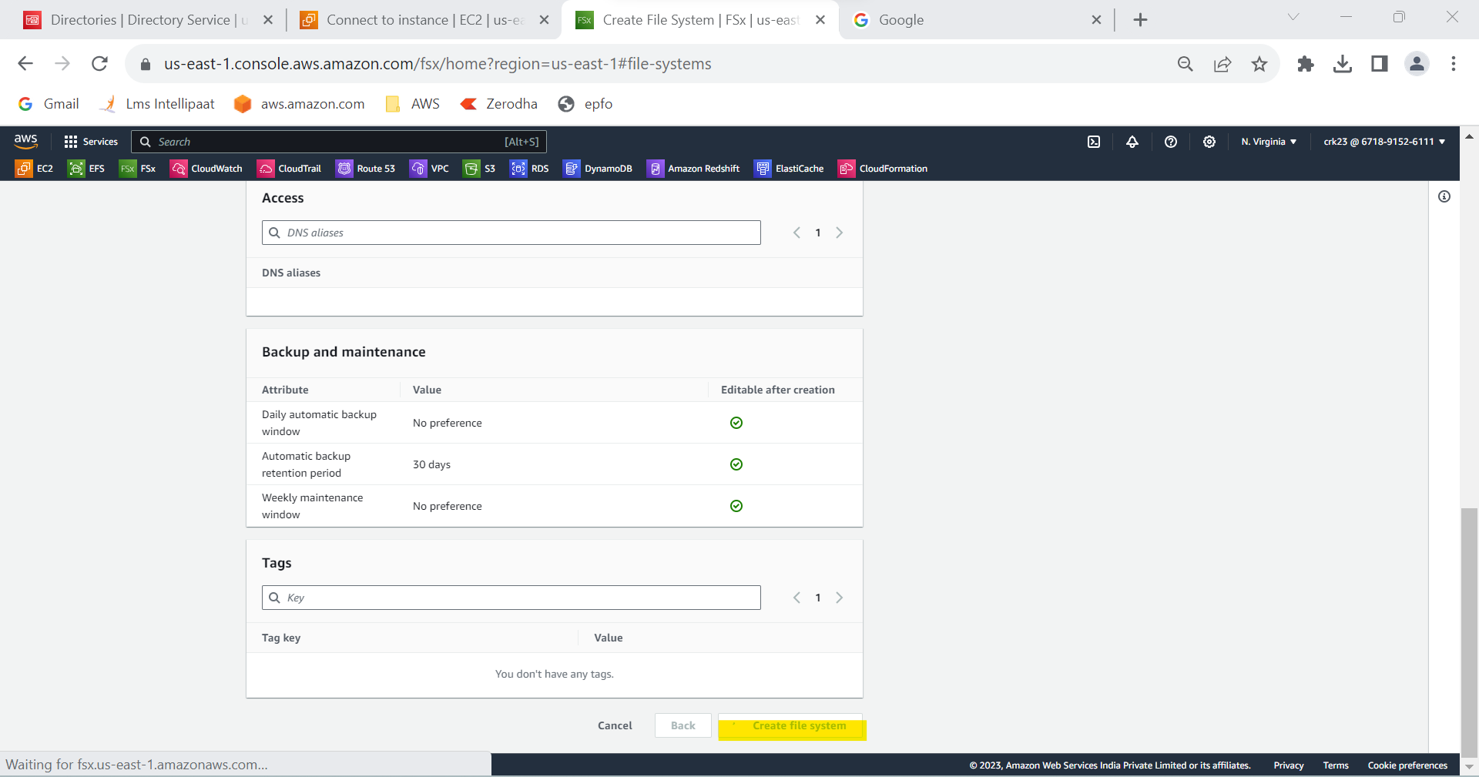

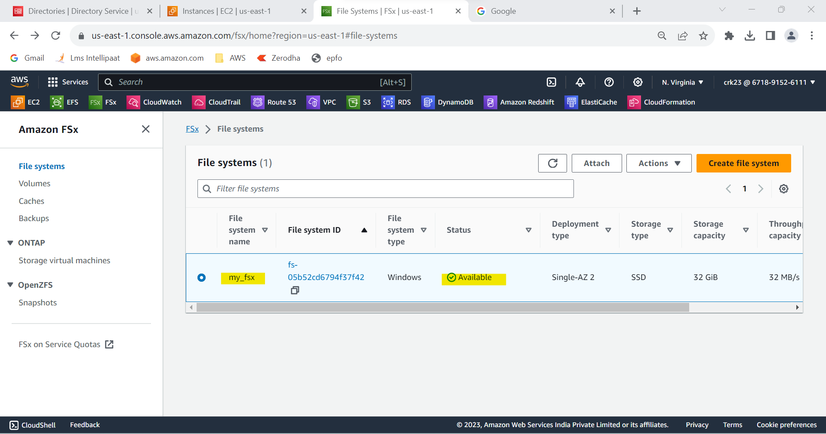

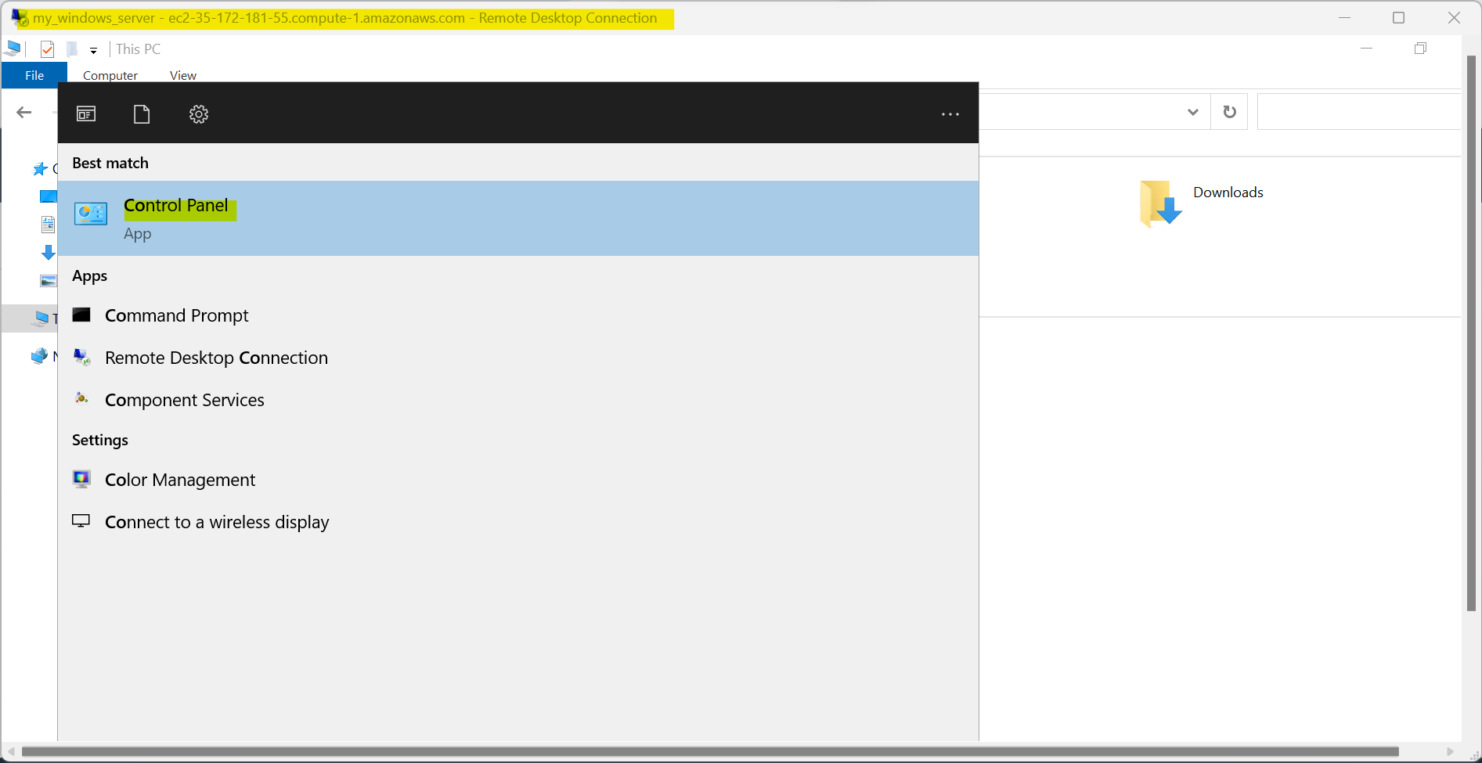

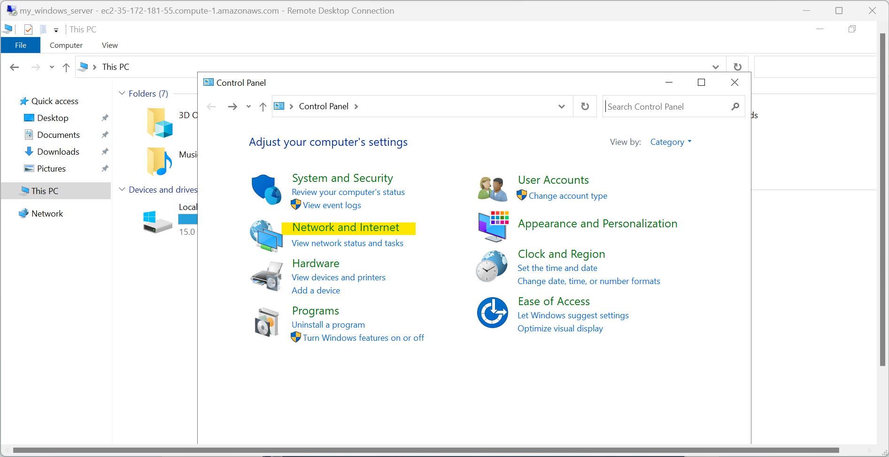

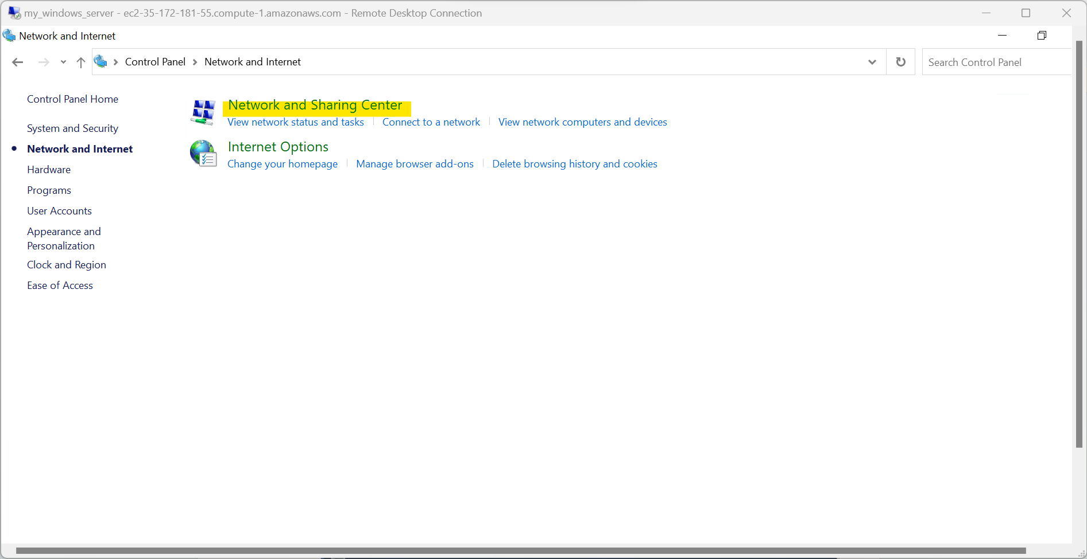

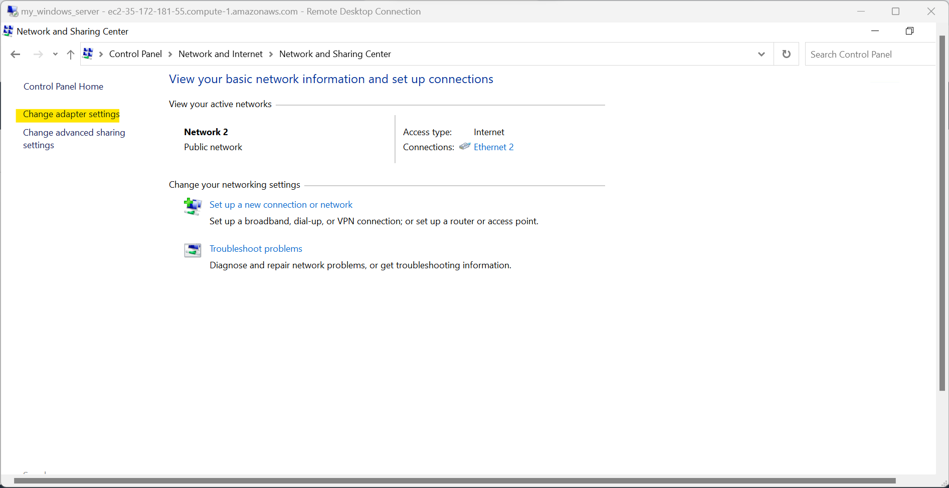

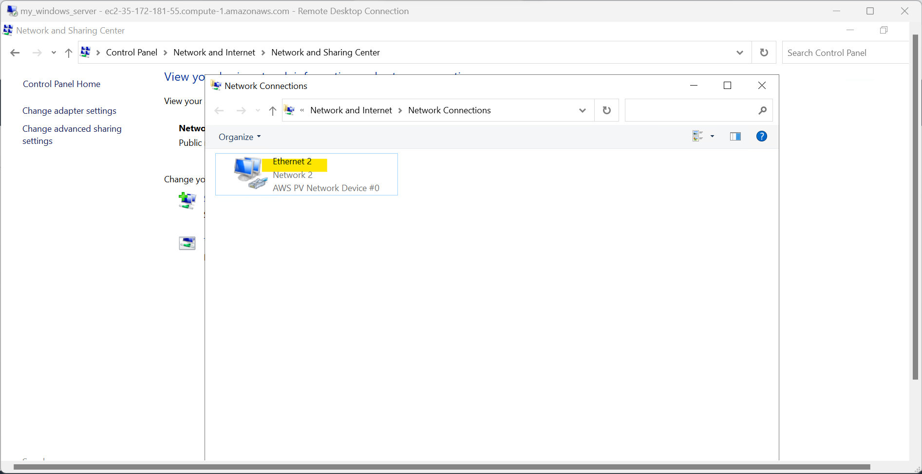

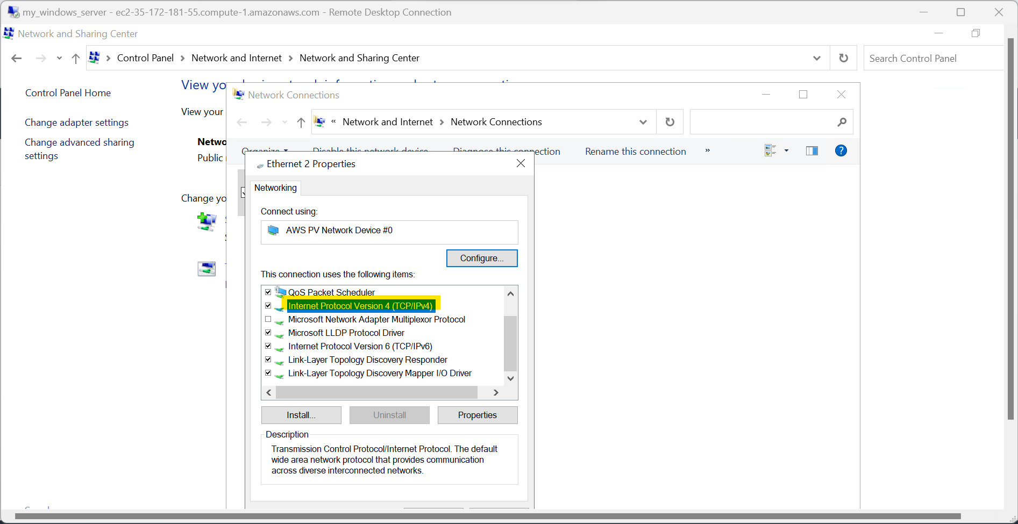

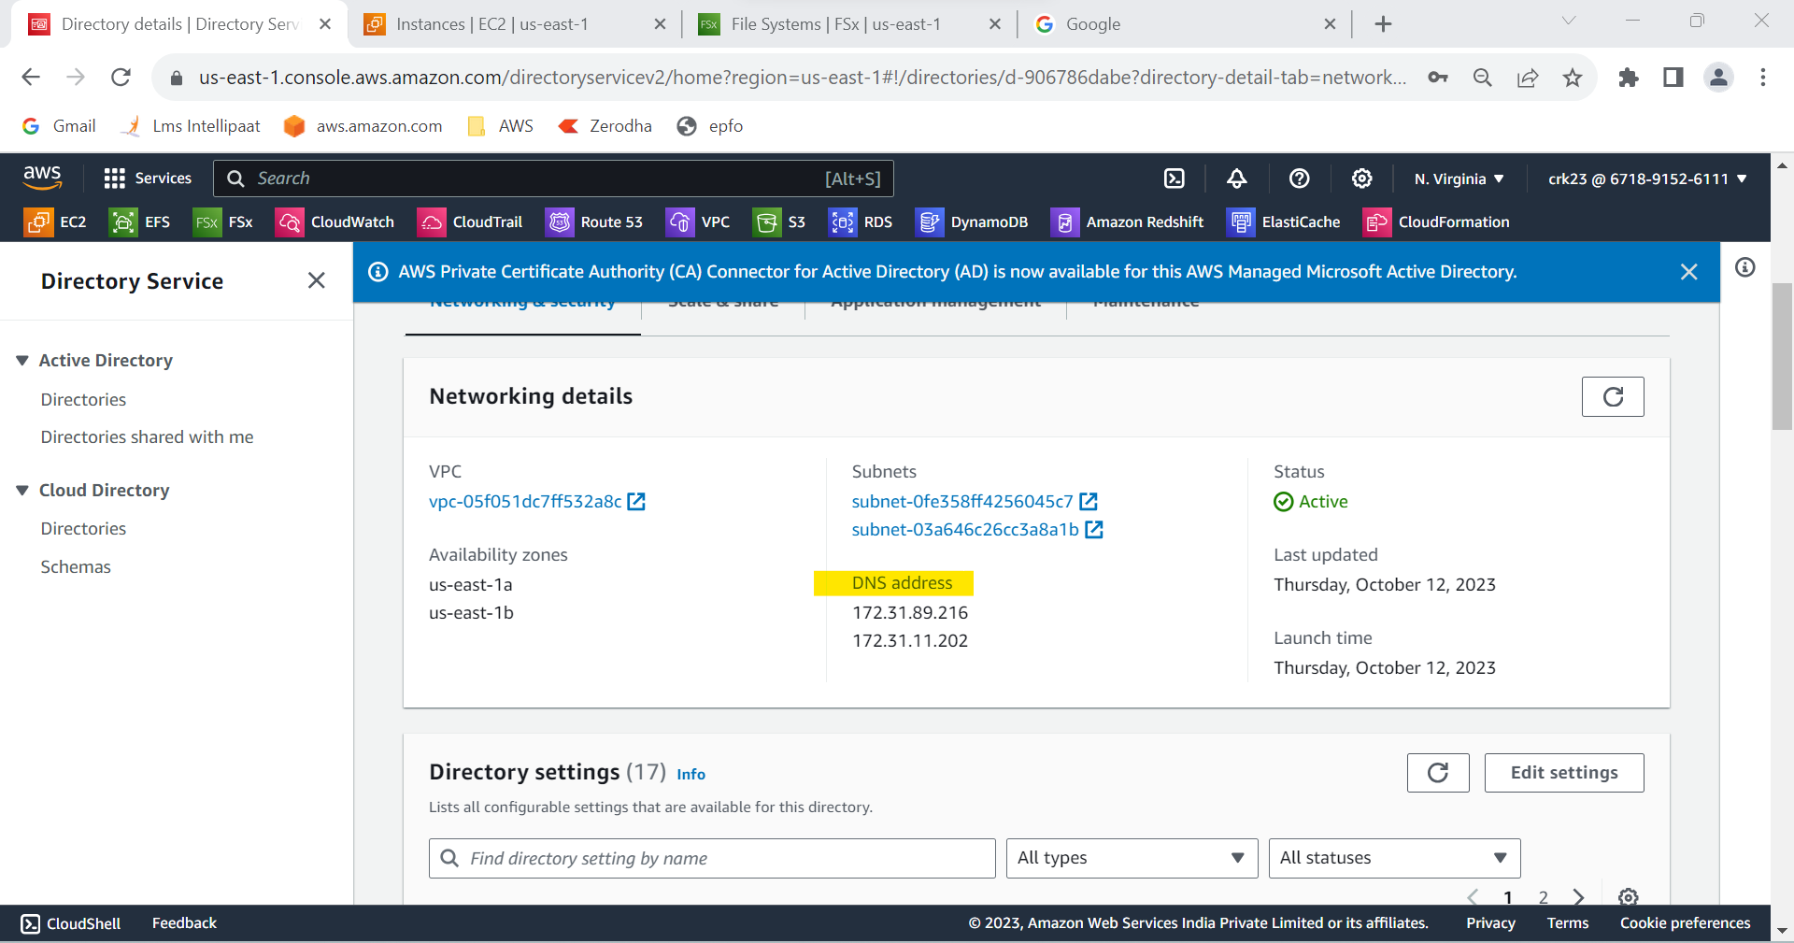

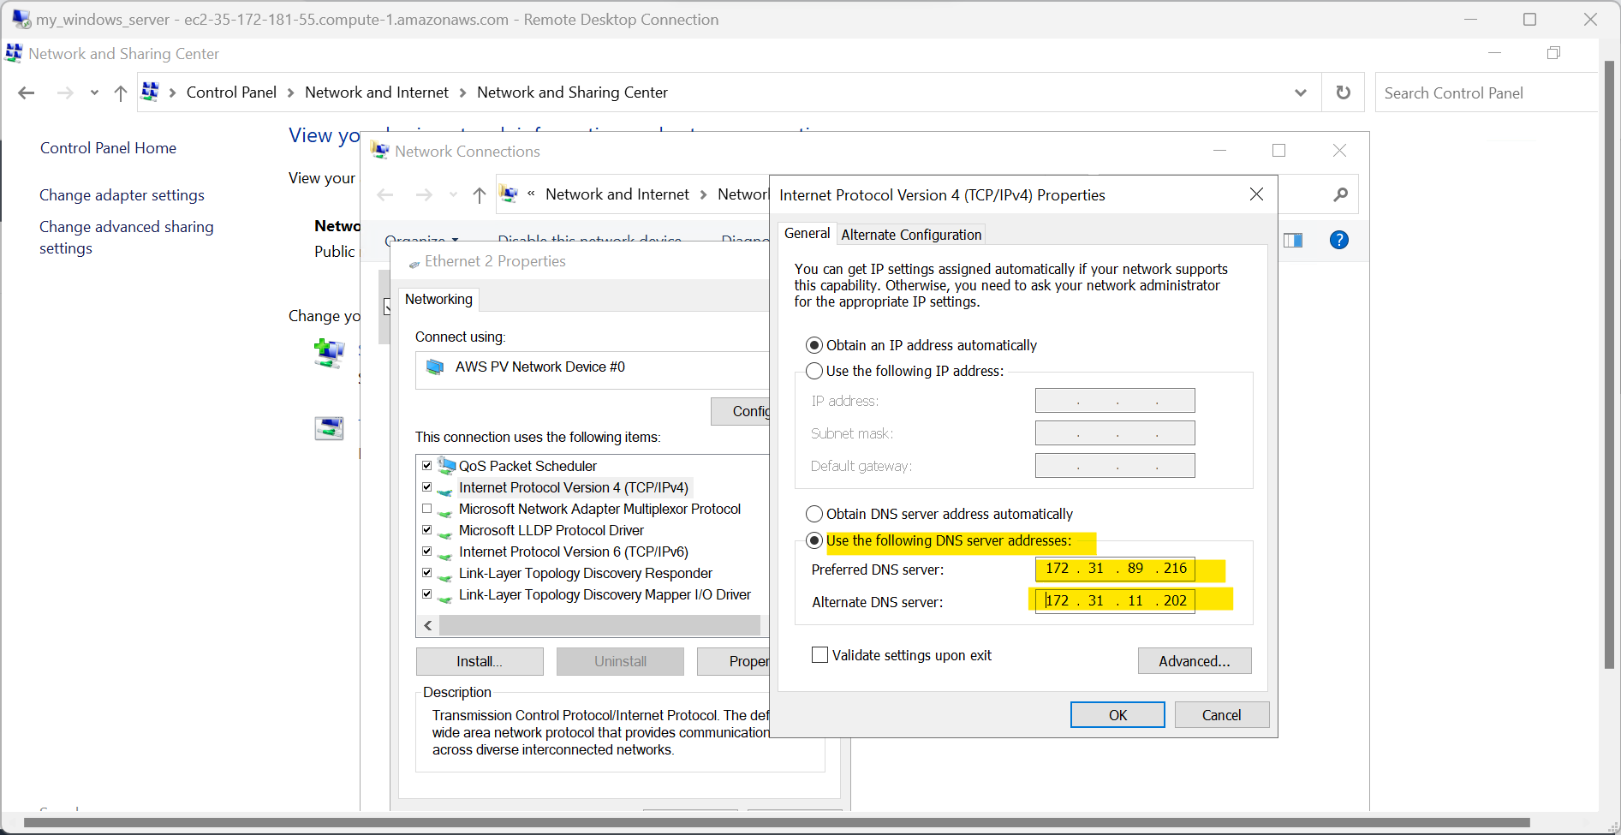

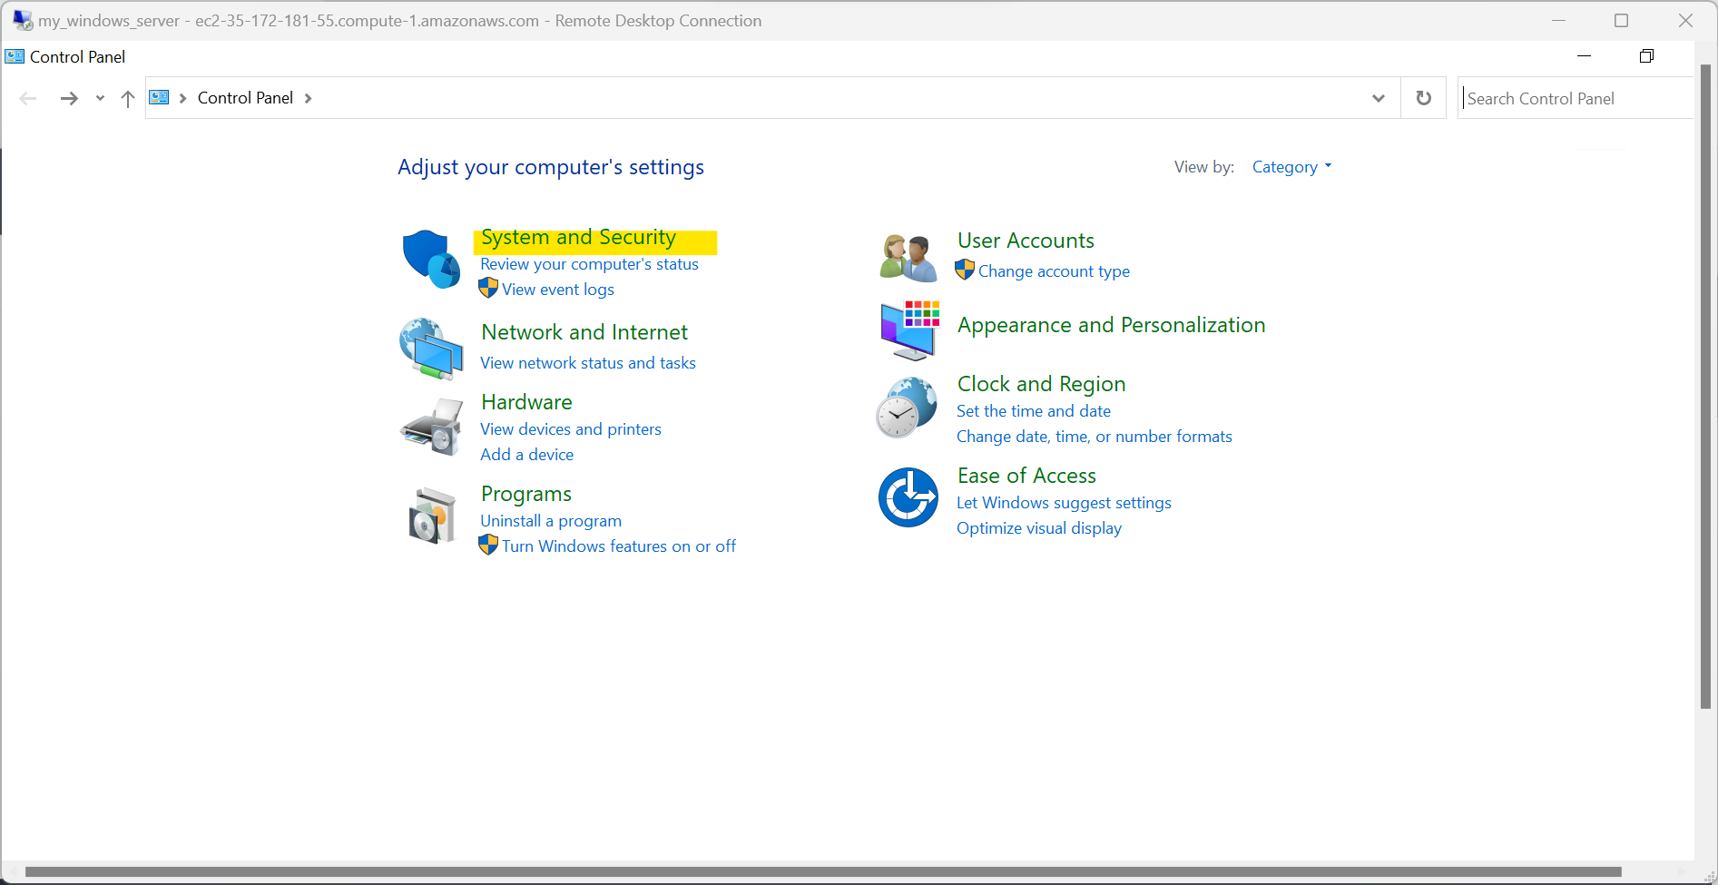

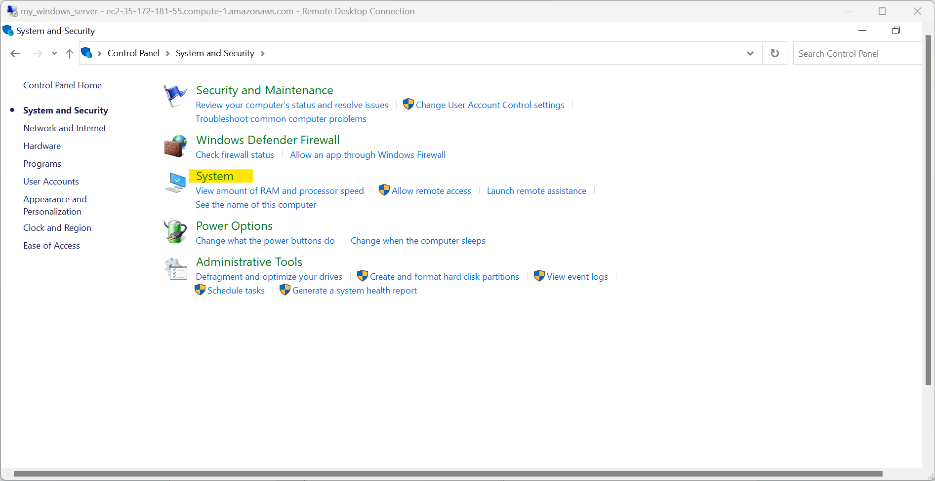

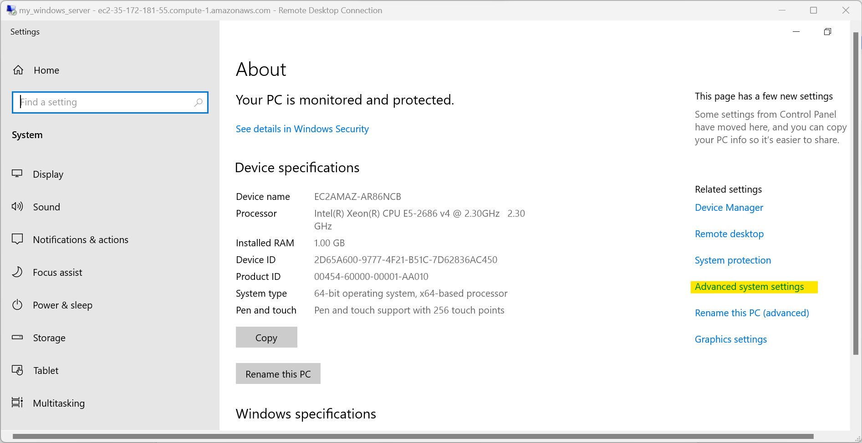

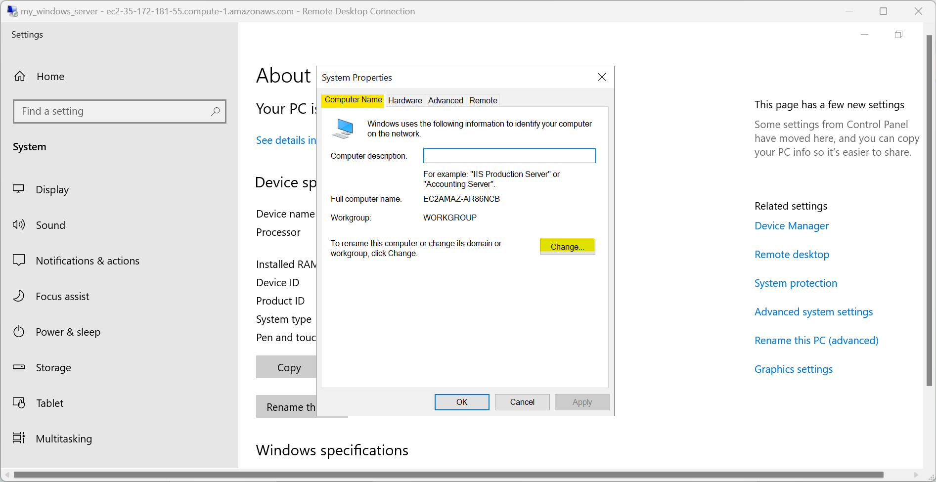

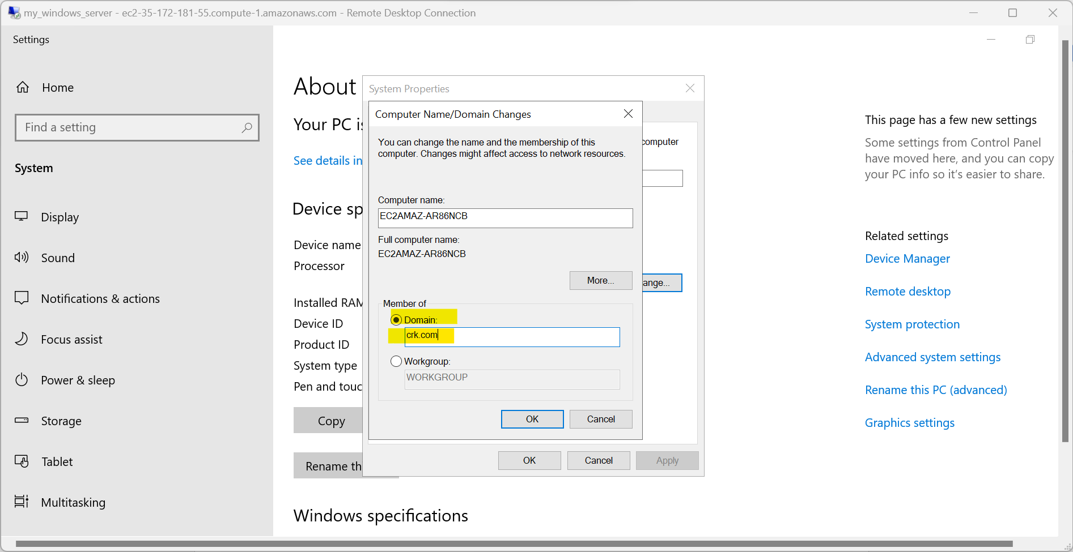

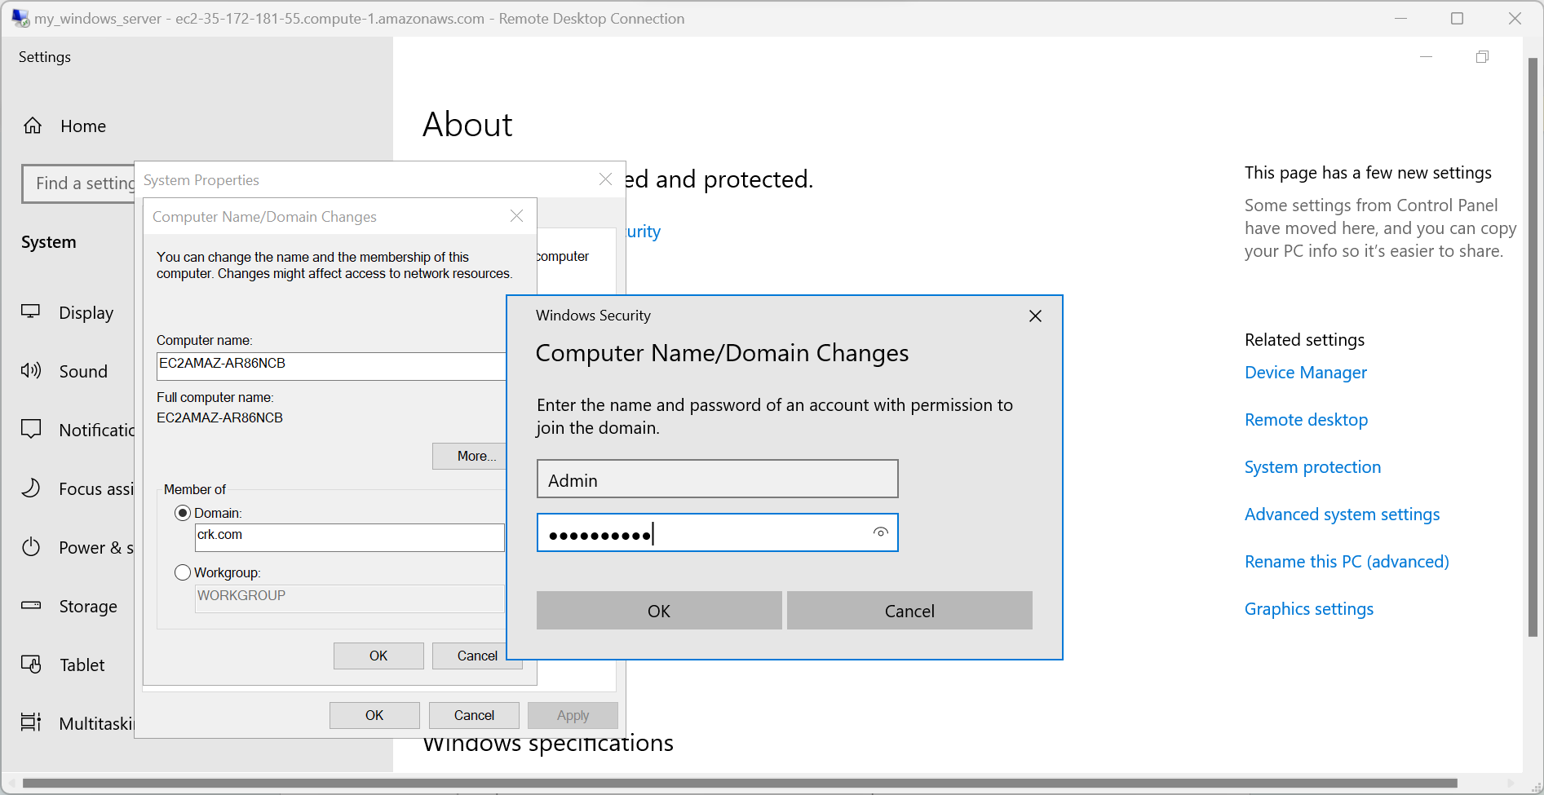

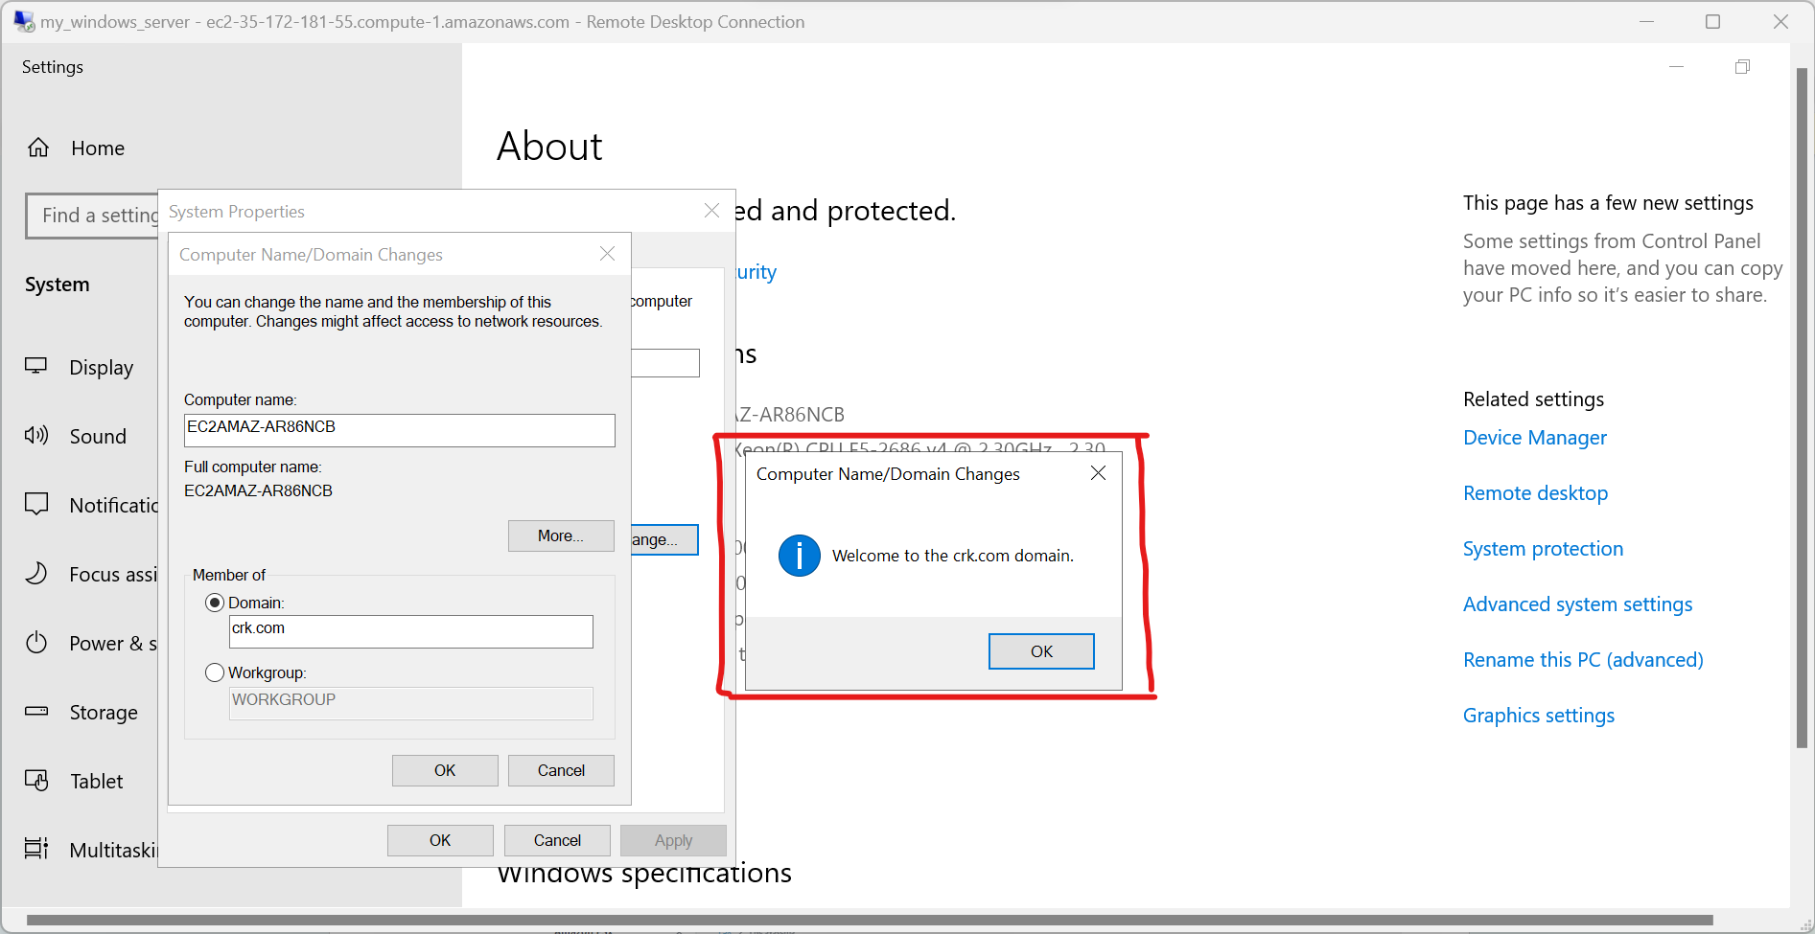

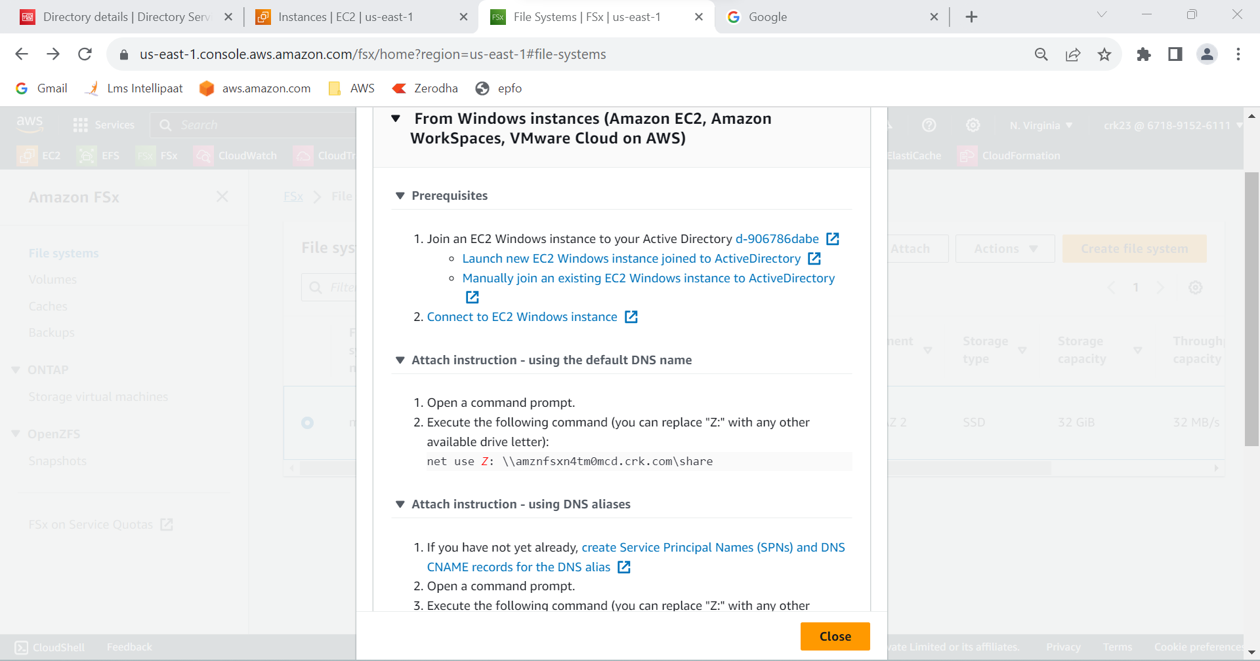

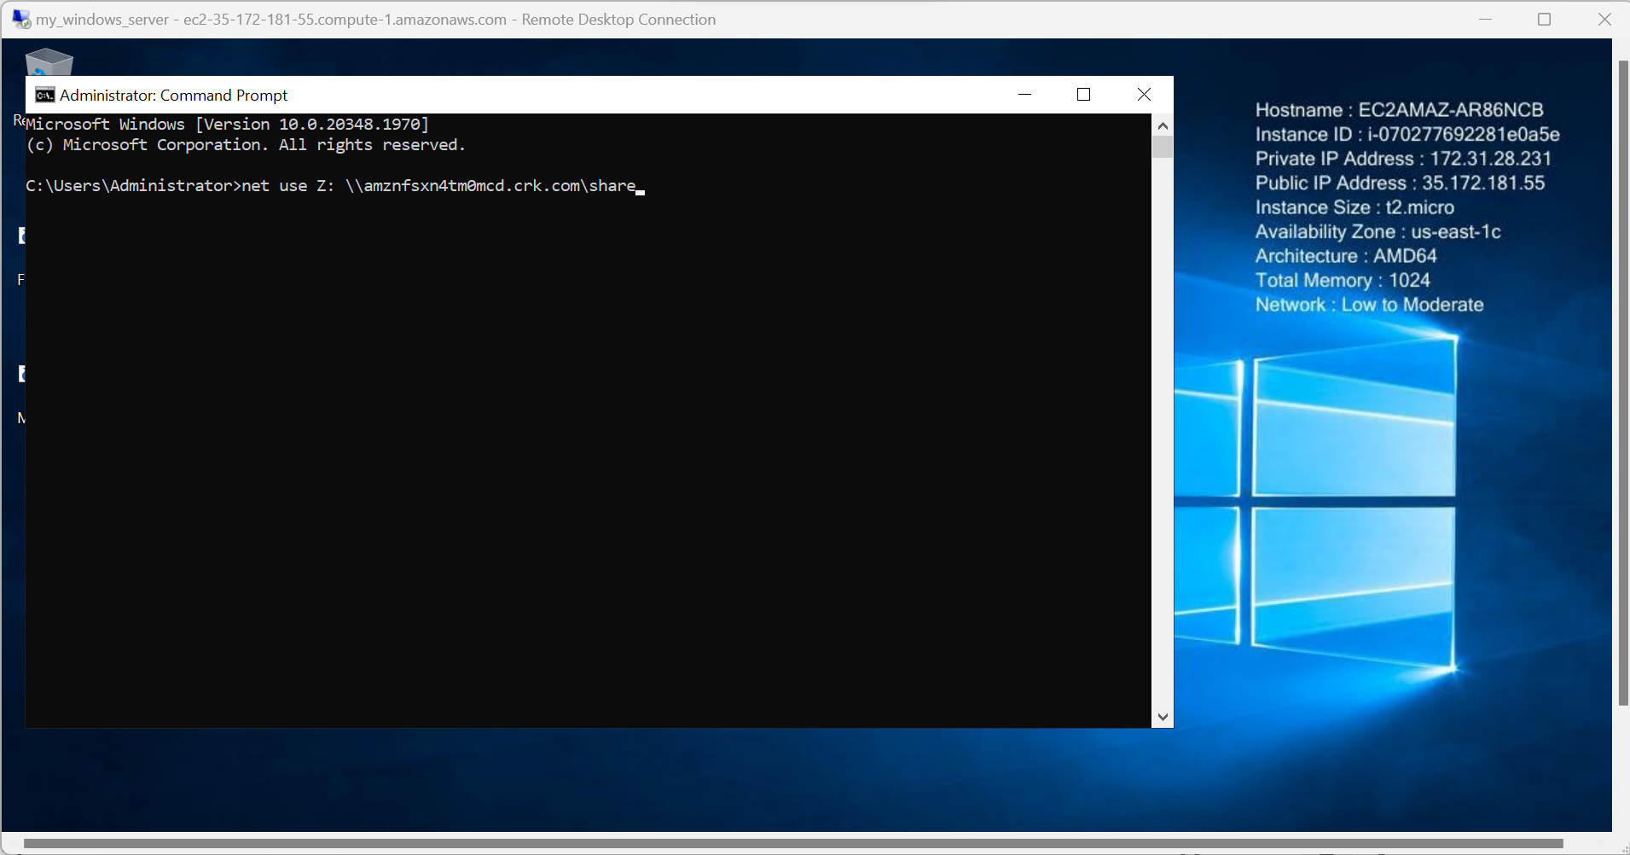

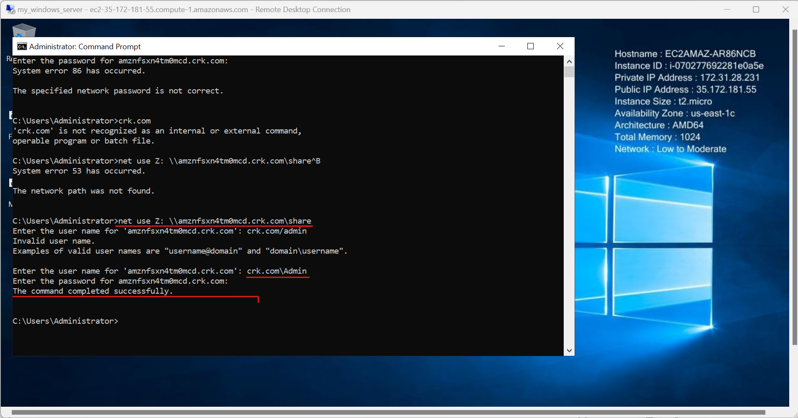

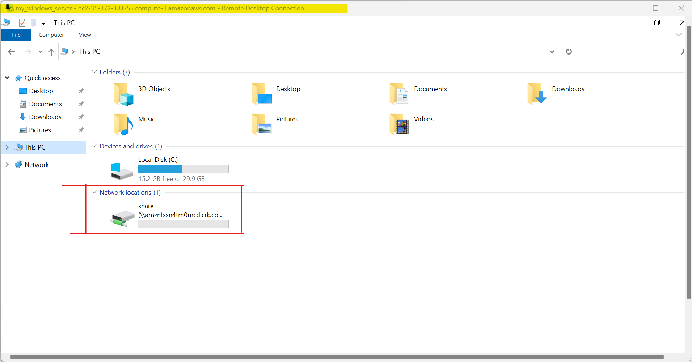

**OUTPUT:**

Created an FSx file system for a Windows file server with AWS Managed Active Directory with a valid domain name in it and xconnected it to the windows server

**2 . Create an FSx file system for Lustre and attach it to an Amazon Linux 2 instance.**

STEP 1 : Open EC2 from aws services

STEP 2 : Launch an linux2 instances

STEP 3 : Before creating afsx for lusture we need to create a security group and add the inbound rule custom tcp , port number and give the security group which we added in our EC2 instance.

STEP 4 : And add another inbound rules as custom tcp, port number and security group named as my_linux_sg (which we have a created)

And save the rules.

STEP 5 : Open Fsx and select fsx for lusture

STEP 6 : Select necessary information need for the lusture and created files system

STEP 7 : Now connect the linux EC2 instance

STEP 8 : Then install the Lustre client on Amazon Linux 2 using this command :- **sudo amazon-linux-extras install -y lustre**

STEP 9 : To attach the Fsx to this instance create new directory to your EC2 instance using the command:- **sudo mkdir /fsx**

STEP 10 : To mount the fiile system use the command:- **sudo mount -t lustre -o noatime,flock fs-0c855cd4b16a4ec01.fsx.us-east1.amazonaws.com@tcp:/fqymlbev */fsx***

STEP 11 : Use the command:- **df** to check whether file system mounted



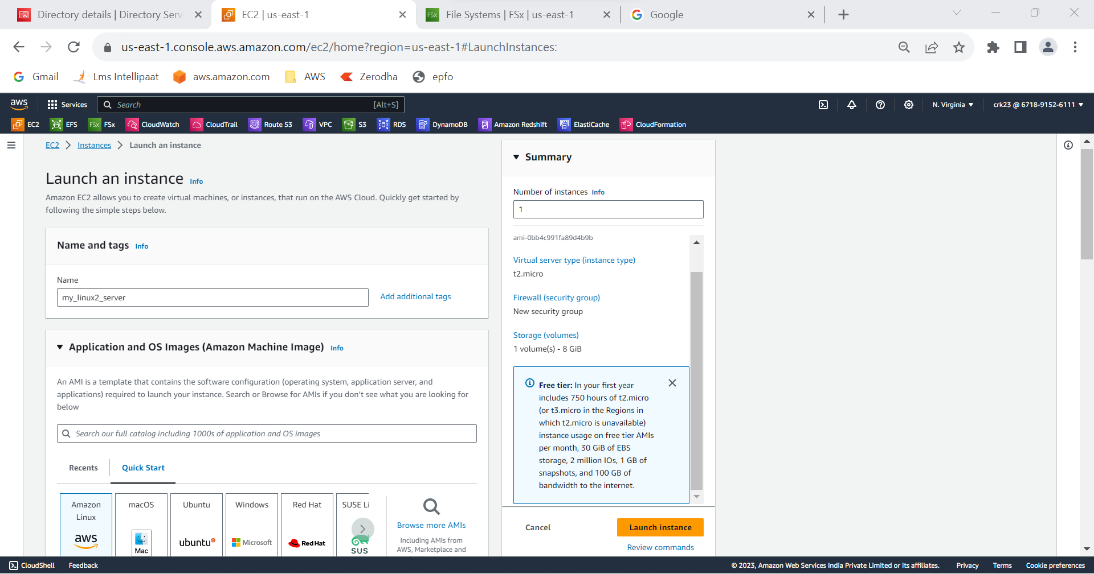

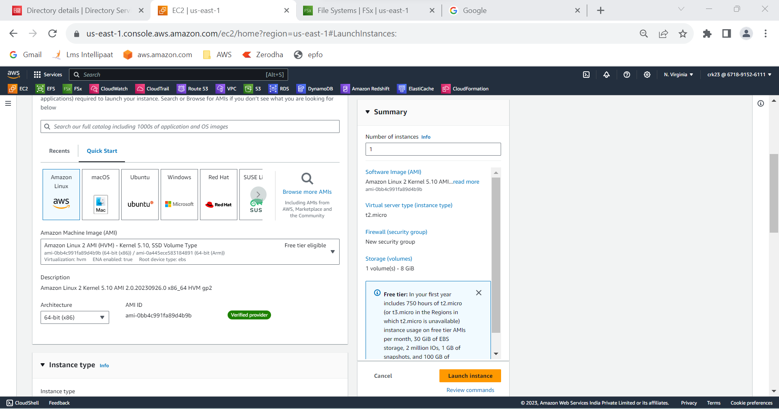

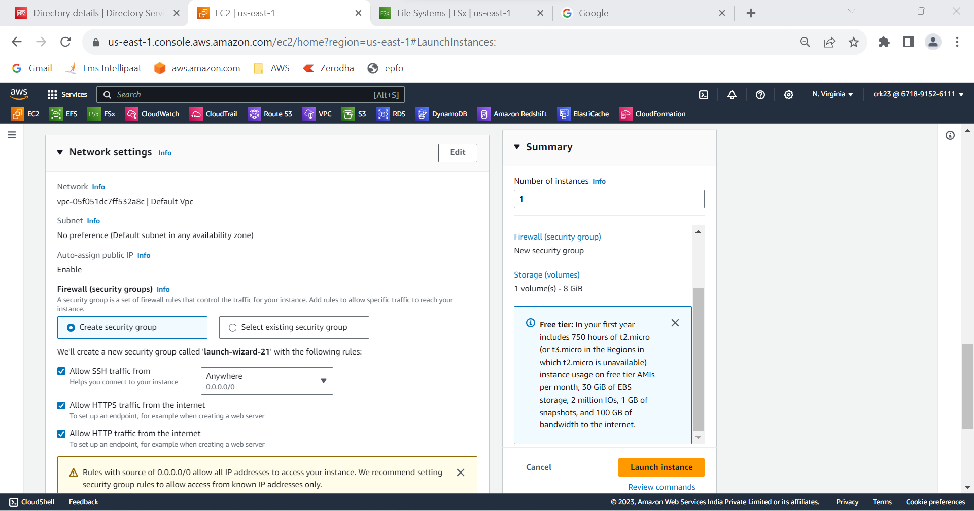

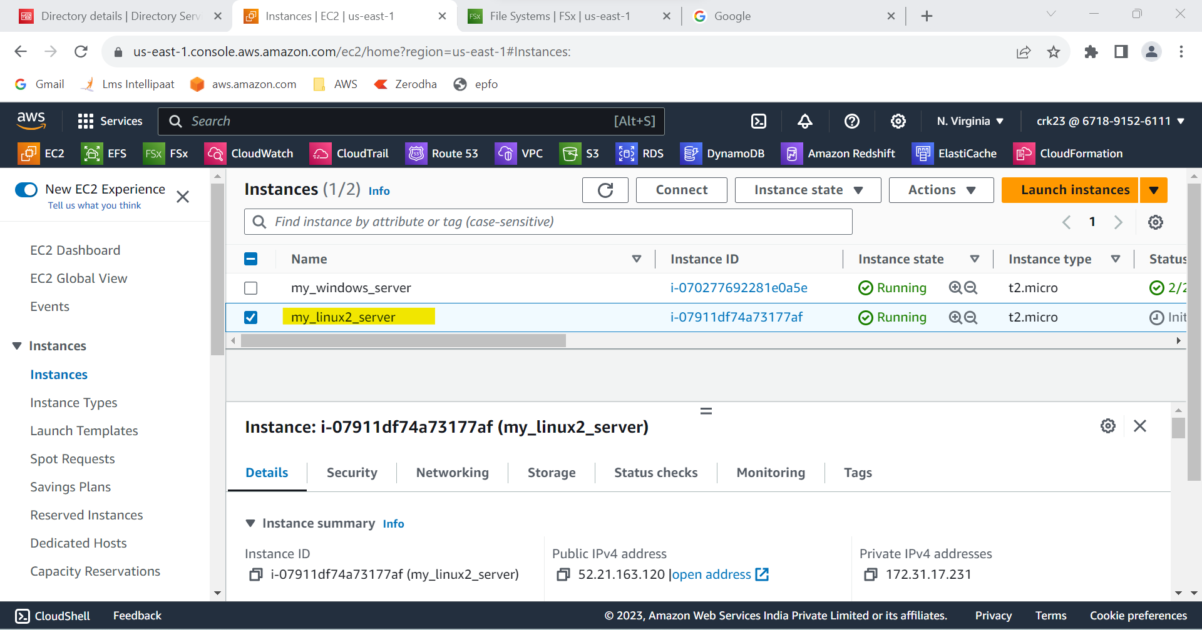

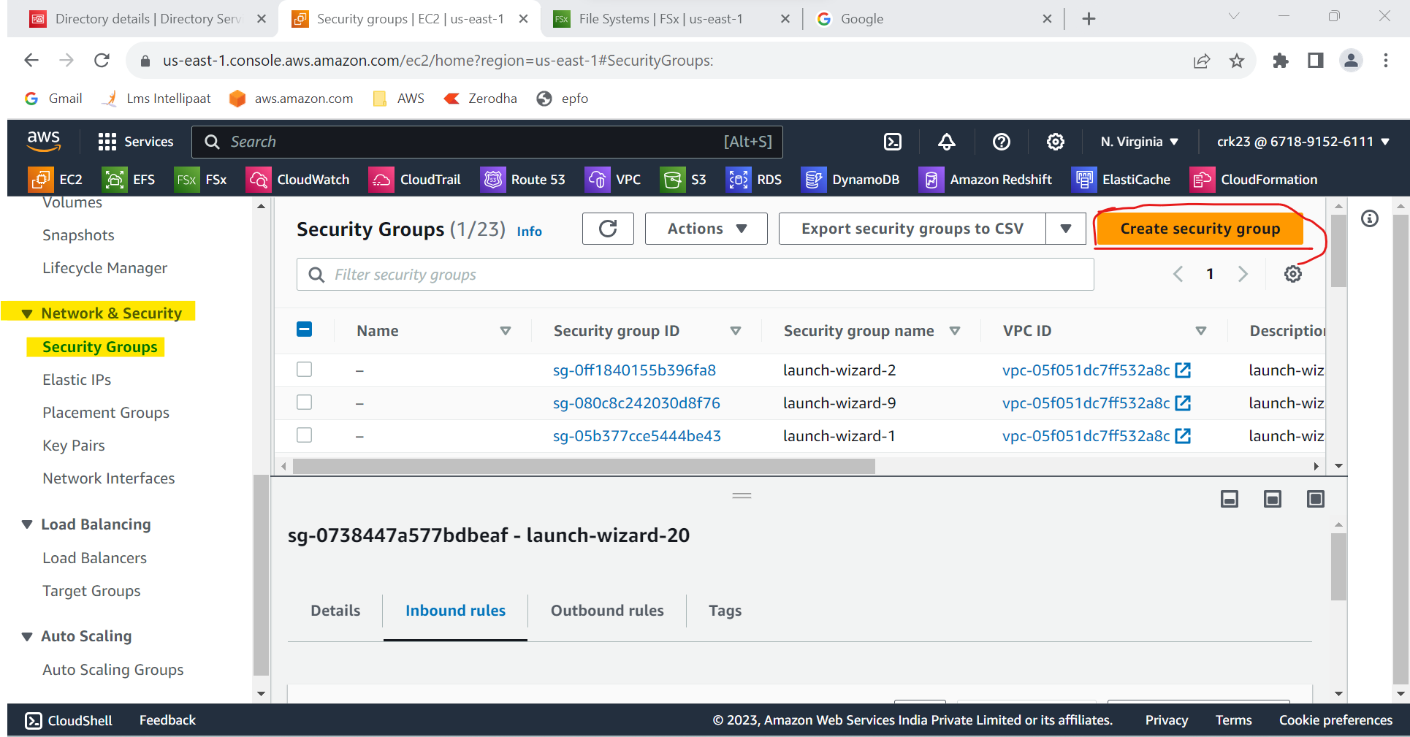

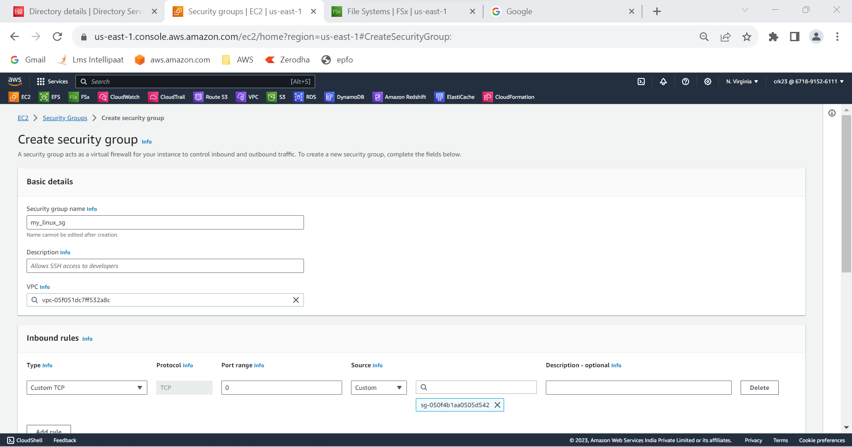

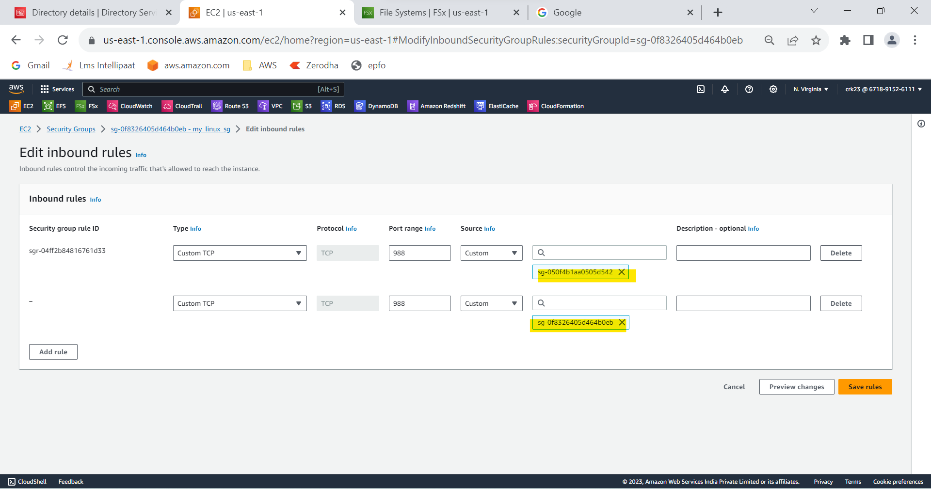

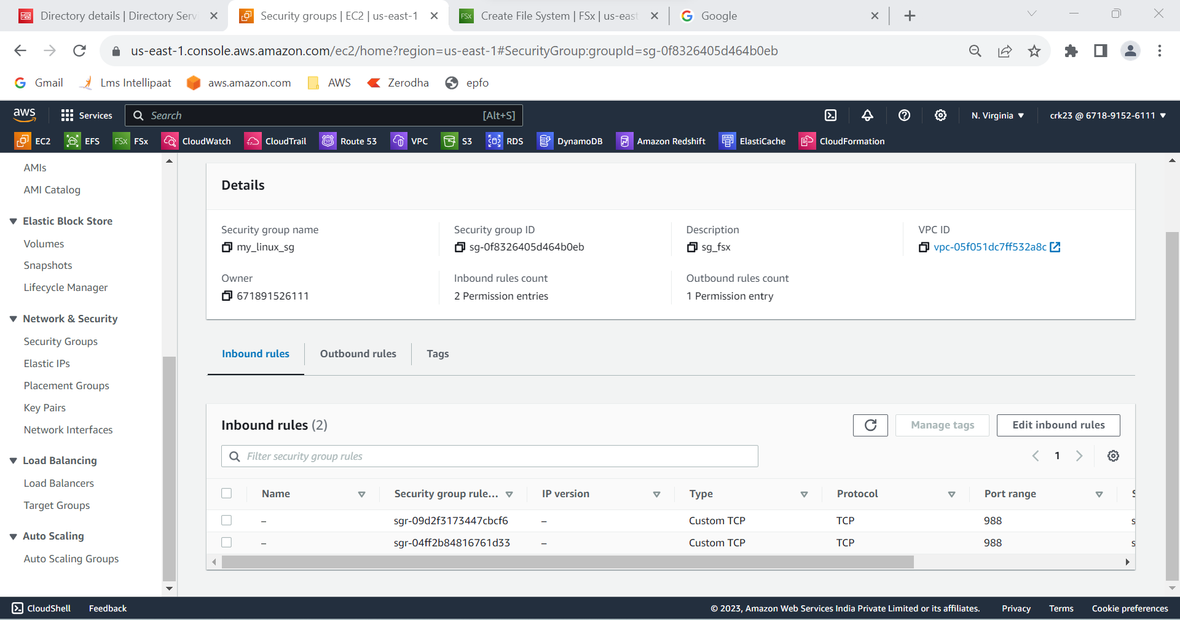

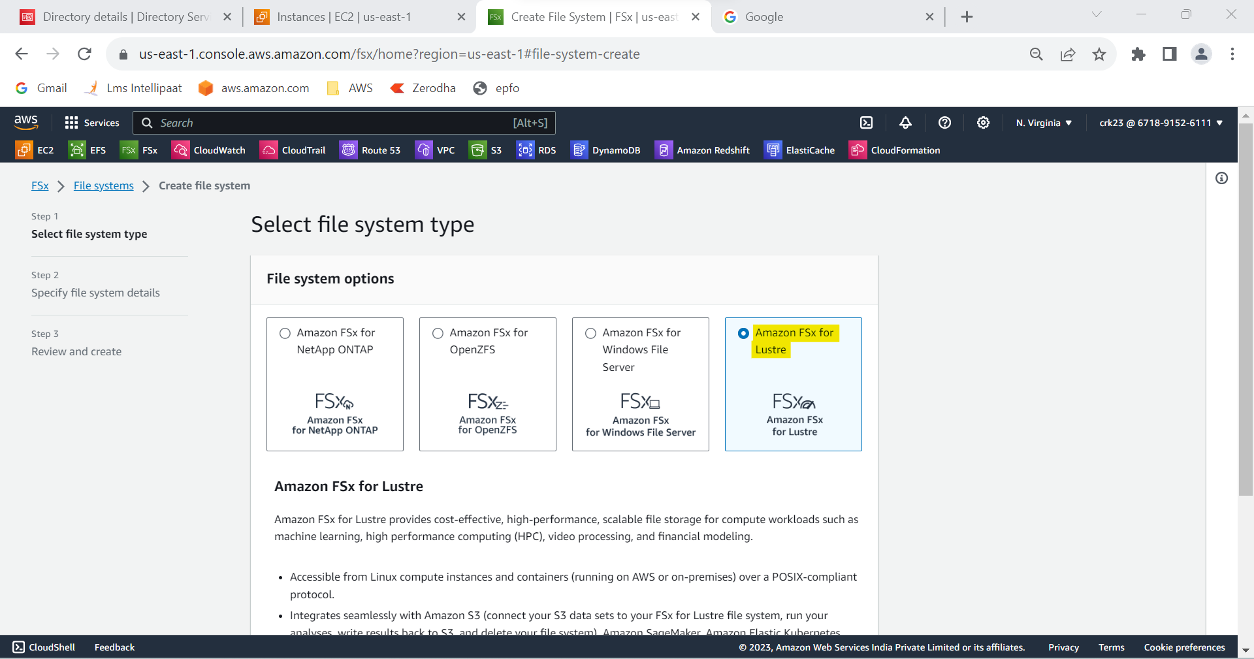

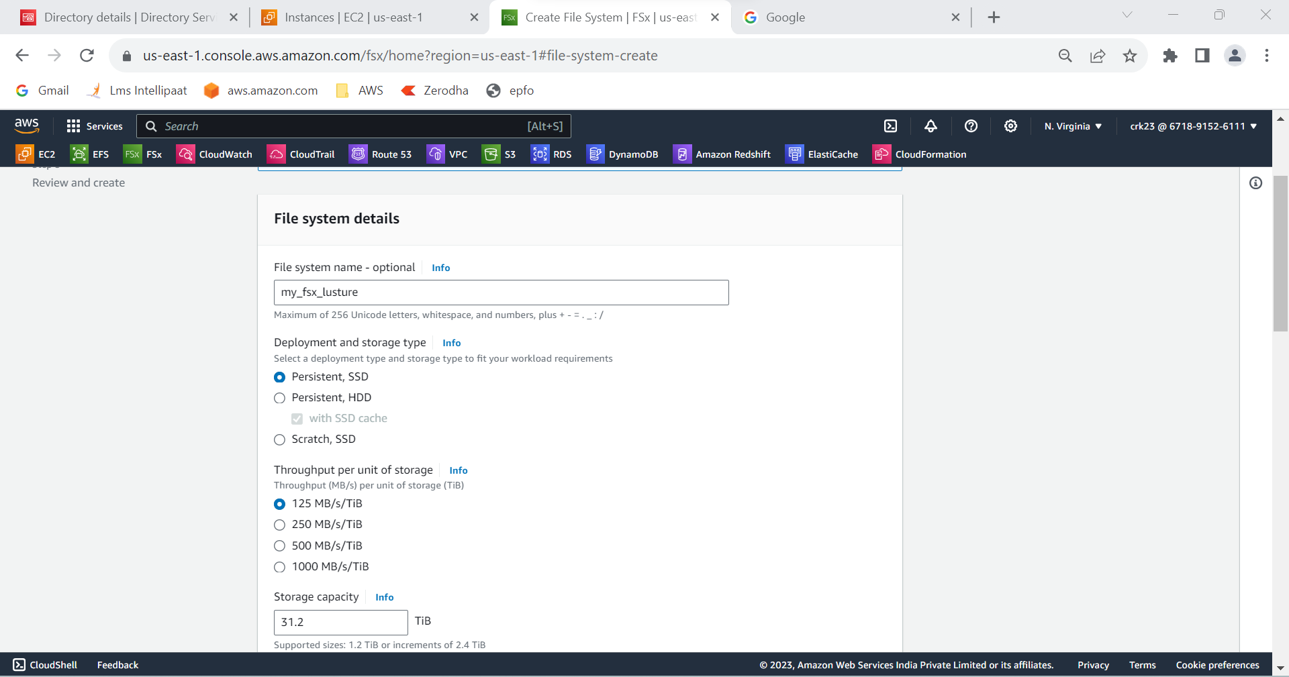

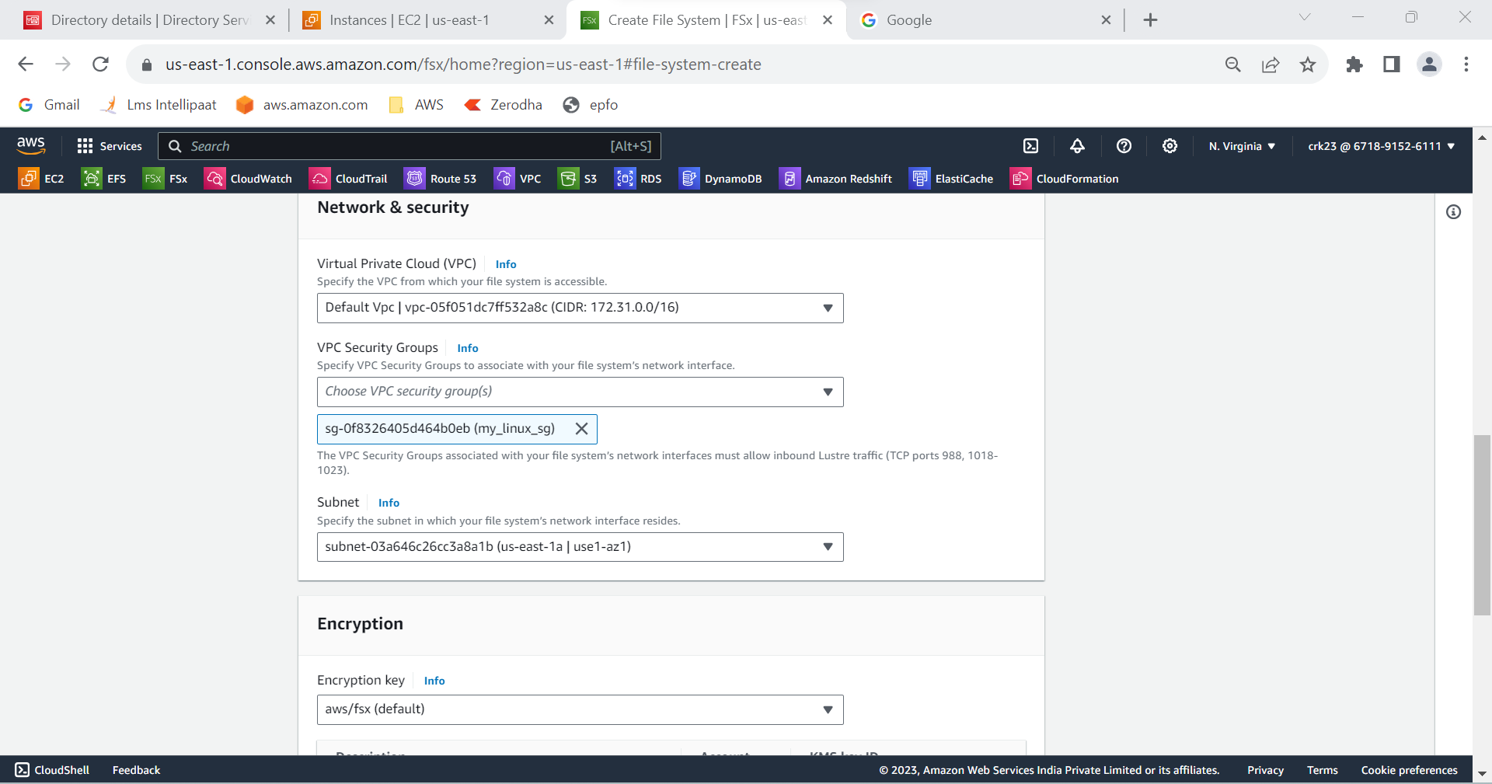

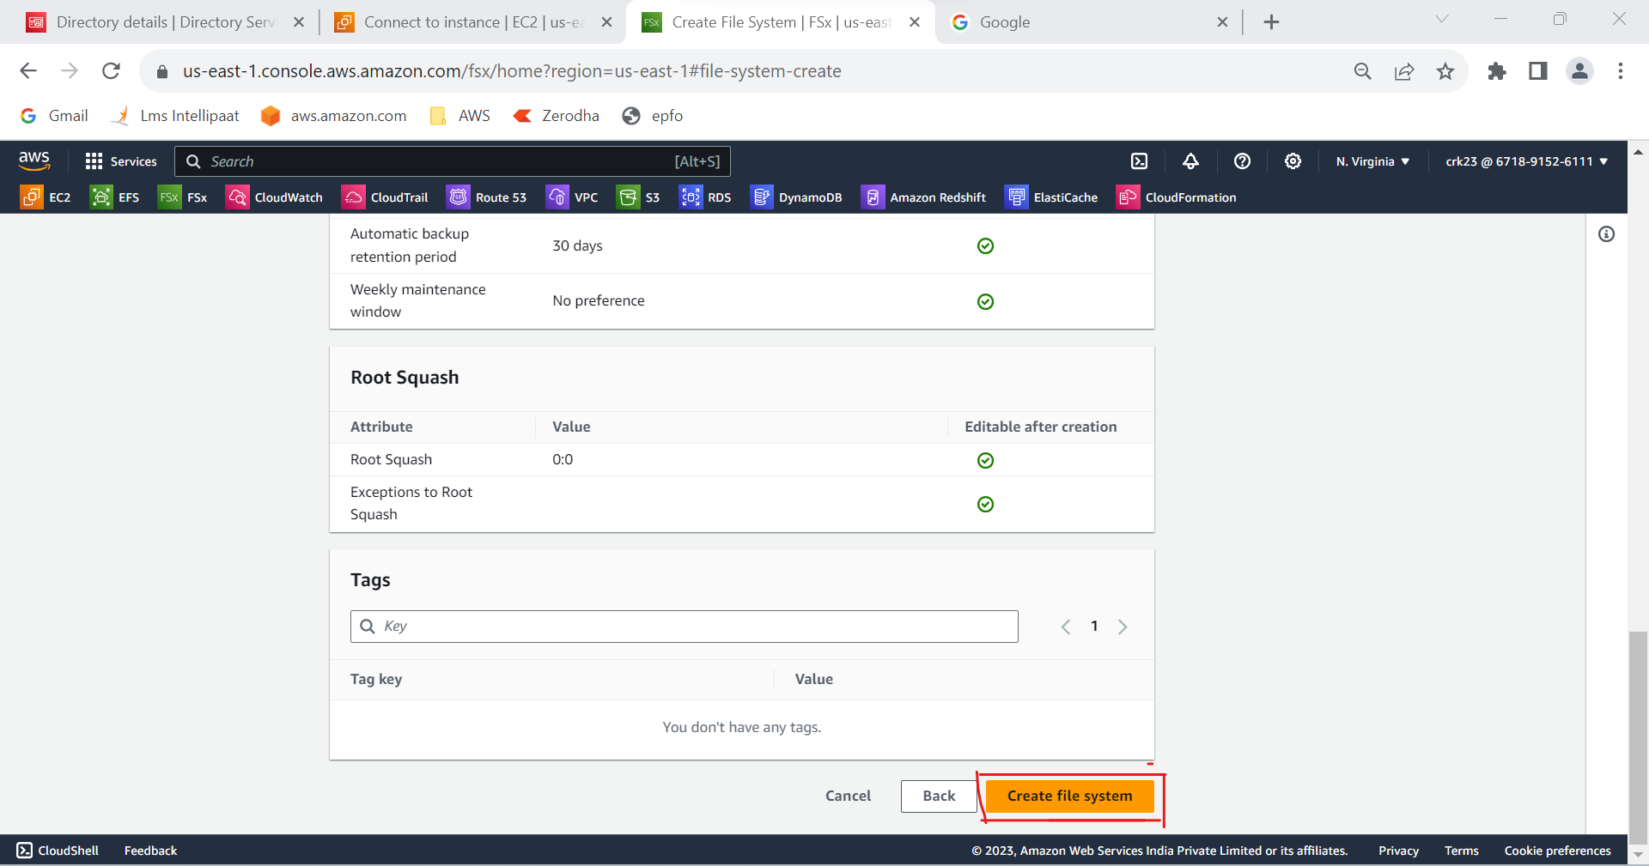

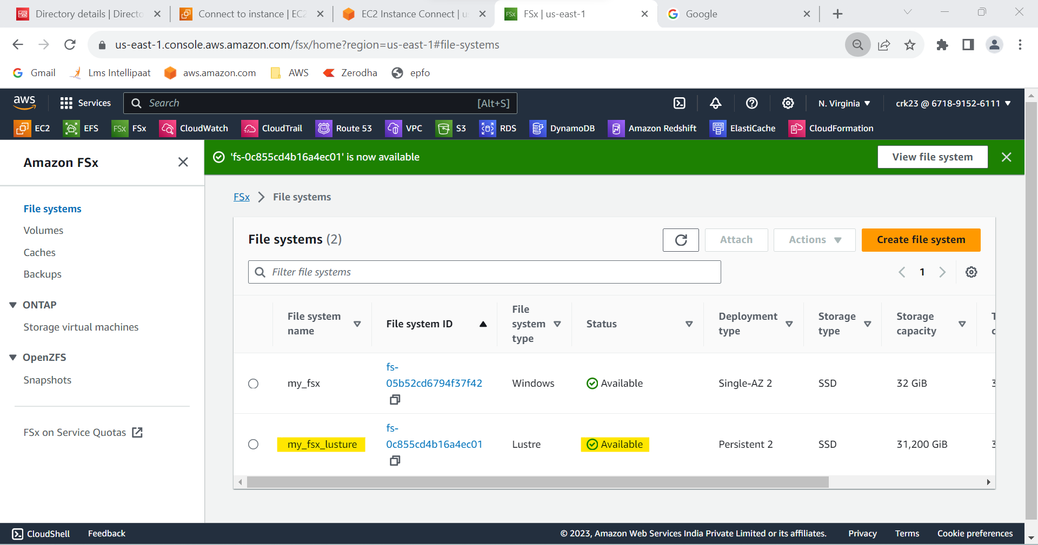

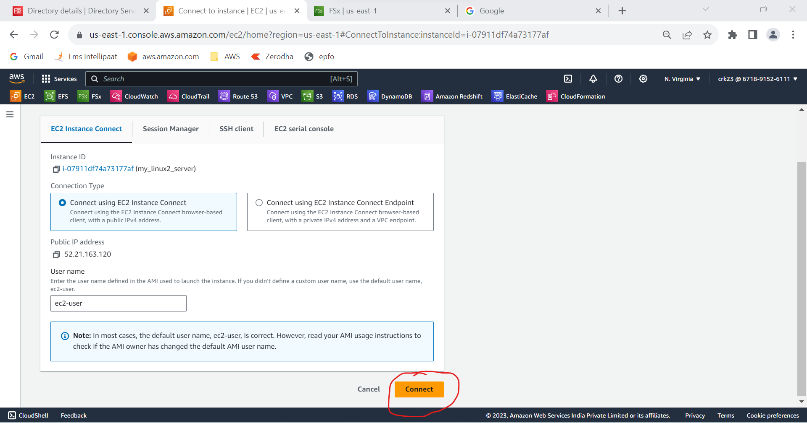

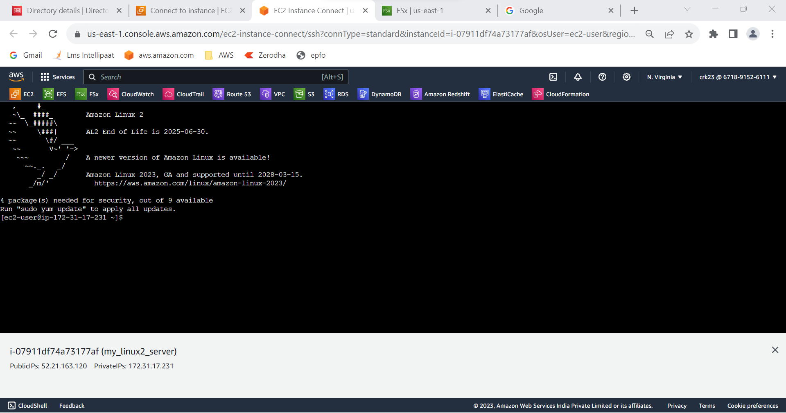

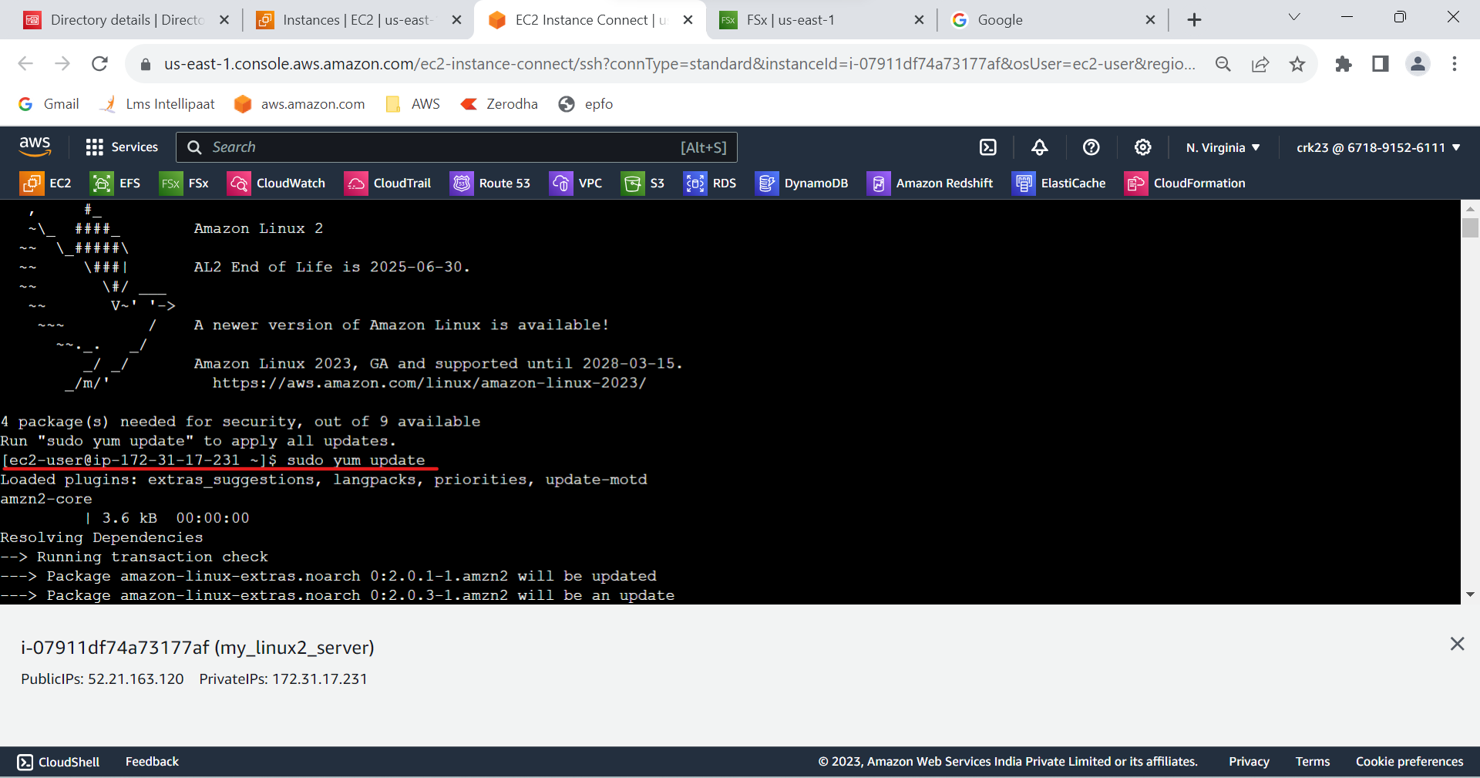

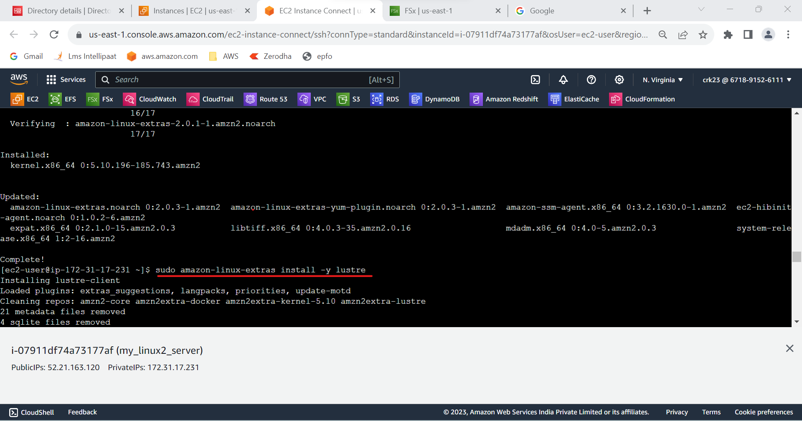

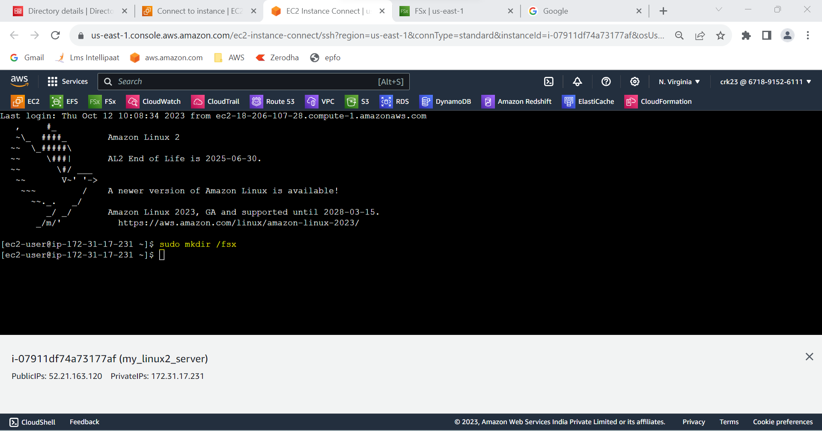

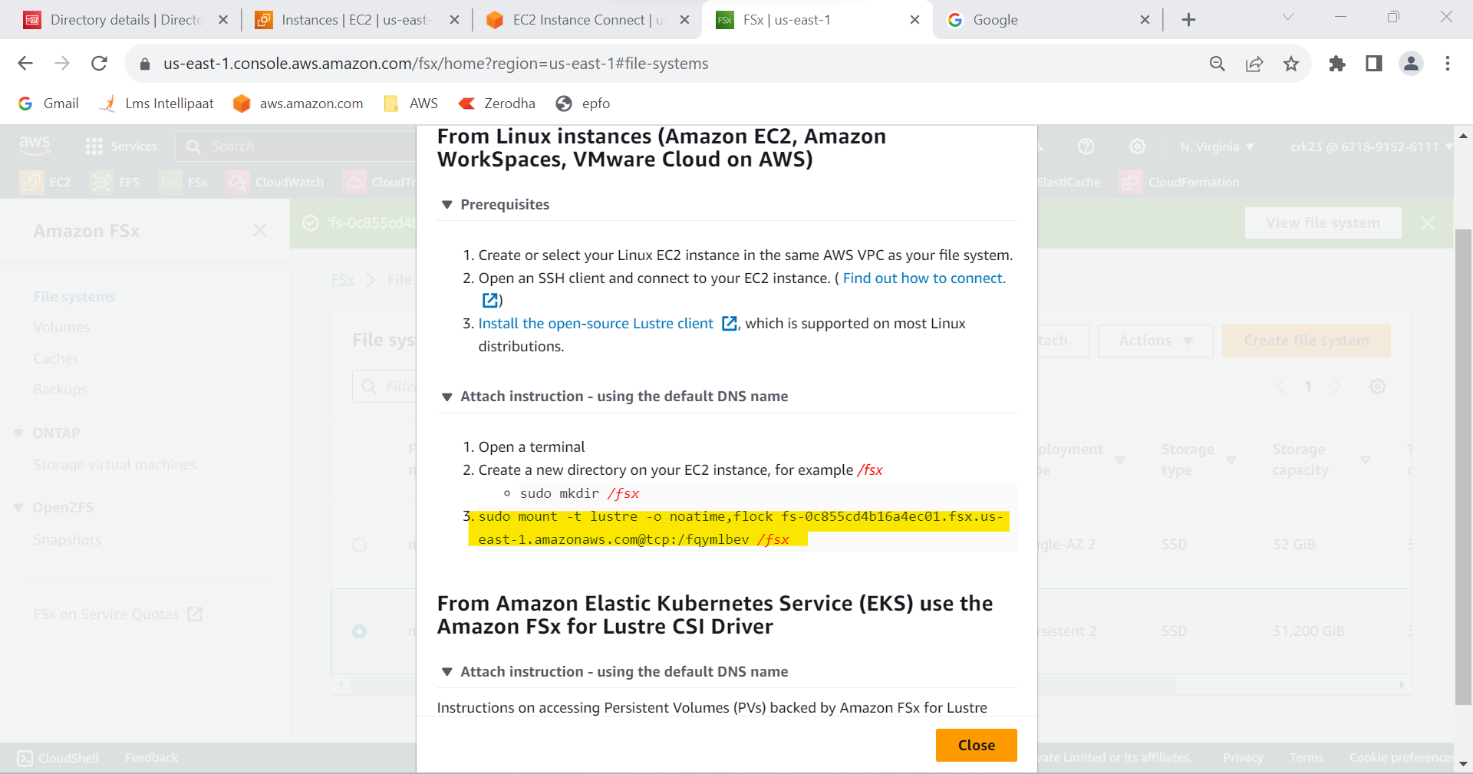

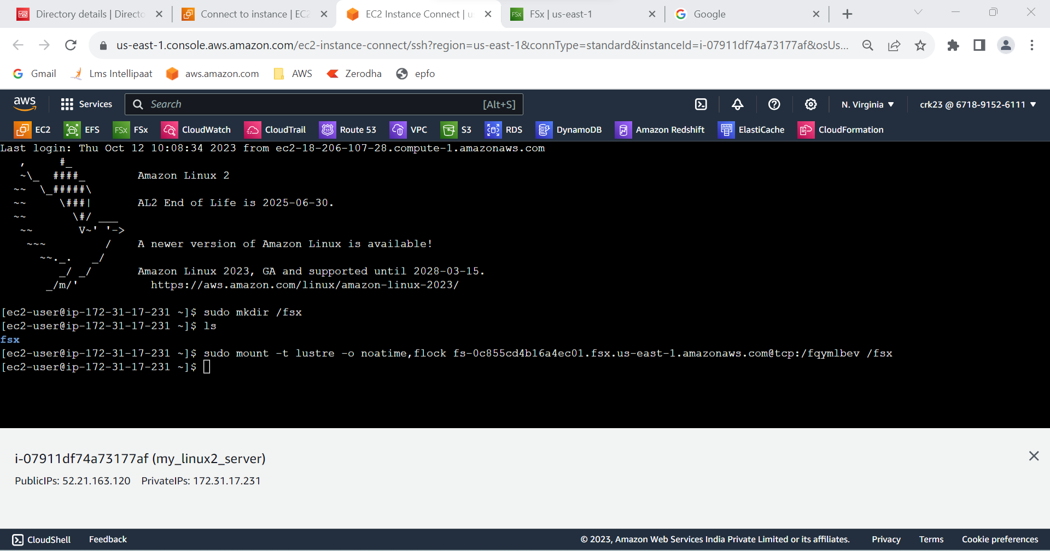

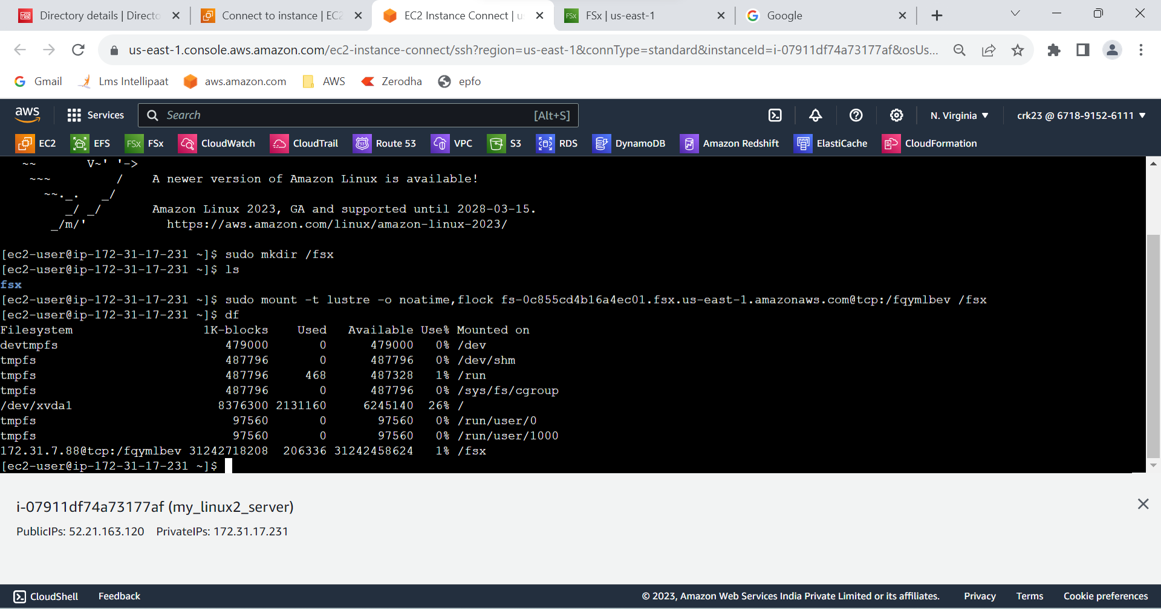

**OUTPUT :**

Created an FSx file system for Lustre and attached it to an Amazon Linux 2 instance.